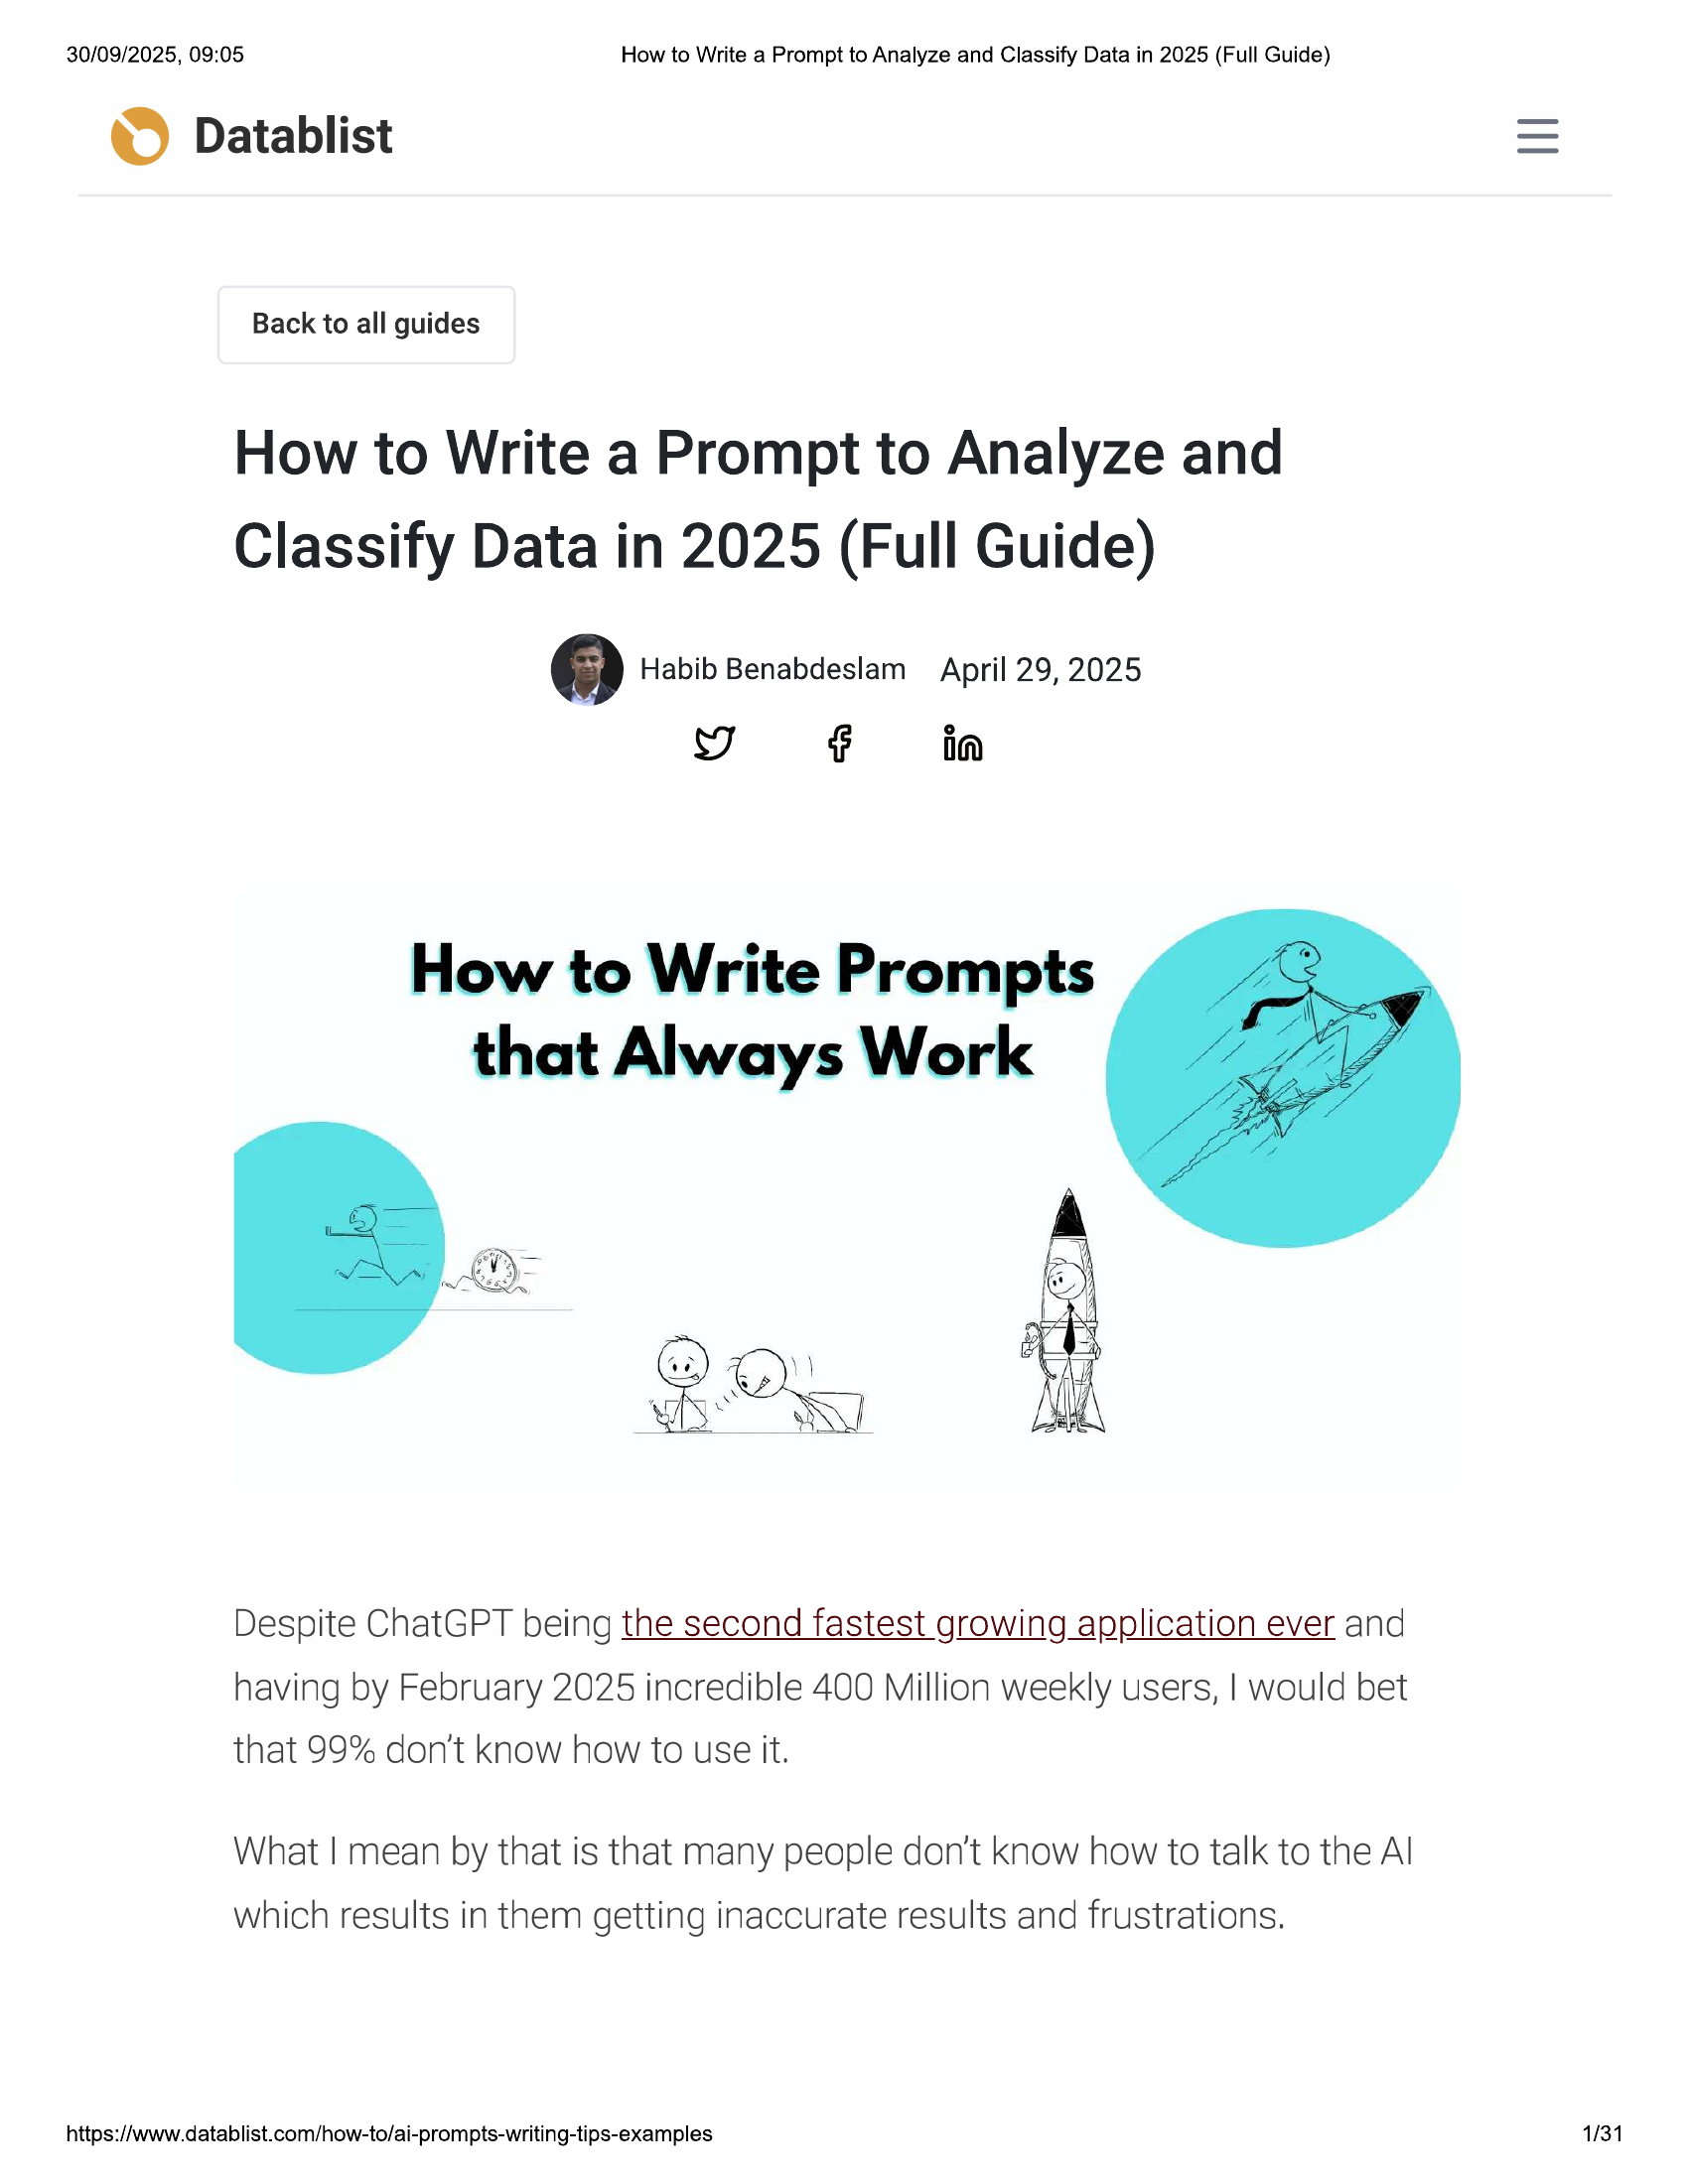

30/09/2025, 09:05 How to Write a Prompt to Analyze and Classify Data in 2025 (Full Guide)  
  
© Datablist  
  
Back to all guides  
  
How to Write a Prompt to Analyze and  
Classify Data in 2025 (Full Guide)  
  
] Habib Benabdeslam April 29, 2025  
YD F — fa  
  
How to Write Prompts  
that Always Work  
  
Key-  
  
in Resdy  
  
WS"  
  
Despite ChatGPT being the second fastest growing application ever and  
having by February 2025 incredible 400 Million weekly users, | would bet  
that 99% don't know how to use it.  
  
What | mean by that is that many people don’t know how to talk to the Al  
which results in them getting inaccurate results and frustrations.  
  
https://www.datablist.com/how-to/ai-prompts-writing-tips-examples 1/31

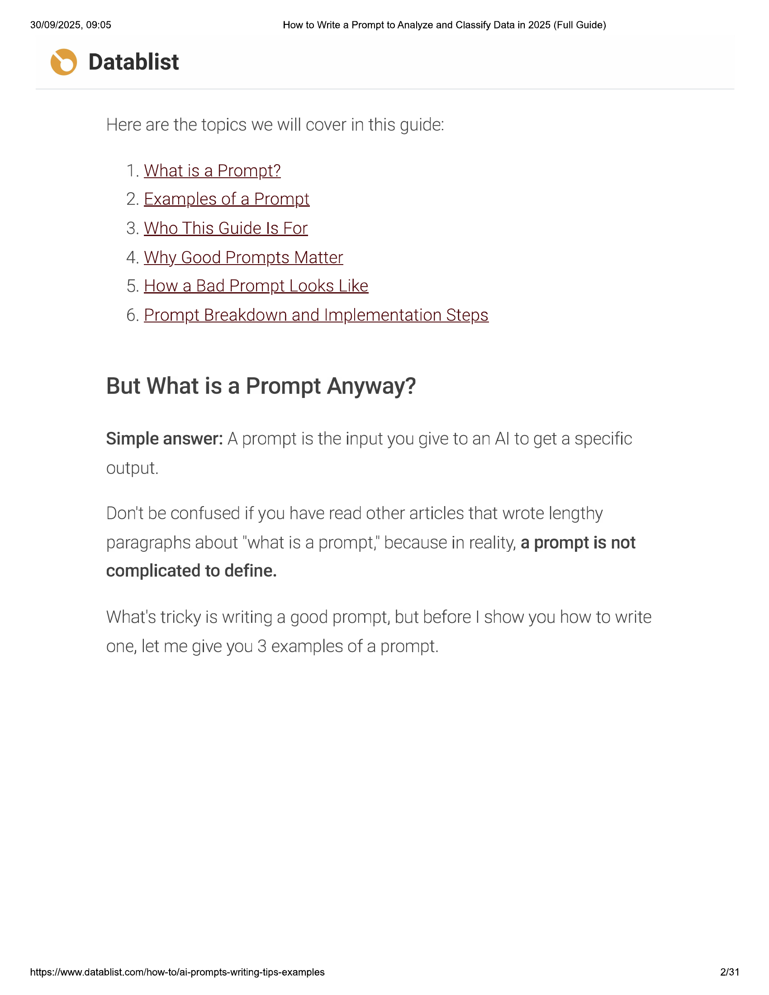

30/09/2025, 09:05 How to Write a Prompt to Analyze and Classify Data in 2025 (Full Guide)  
  
© Datablist  
  
Here are the topics we will cover in this guide:  
  
1. What is a Prompt?  
  
2. Examples of a Prompt  
  
3. Who This Guide Is For  
  
4, Why Good Prompts Matter  
  
5. How a Bad Prompt Looks Like  
  
6. Prompt Breakdown and Implementation Steps  
  
But What is a Prompt Anyway?  
  
Simple answer: A prompt is the input you give to an Al to get a specific  
  
output.  
  
Don't be confused if you have read other articles that wrote lengthy  
paragraphs about "what is a prompt,’ because in reality, a prompt is not  
complicated to define.  
  
What's tricky is writing a good prompt, but before | show you how to write  
one, let me give you 3 examples of a prompt.  
  
https://www.datablist.com/how-to/ai-prompts-writing-tips-examples 2/31

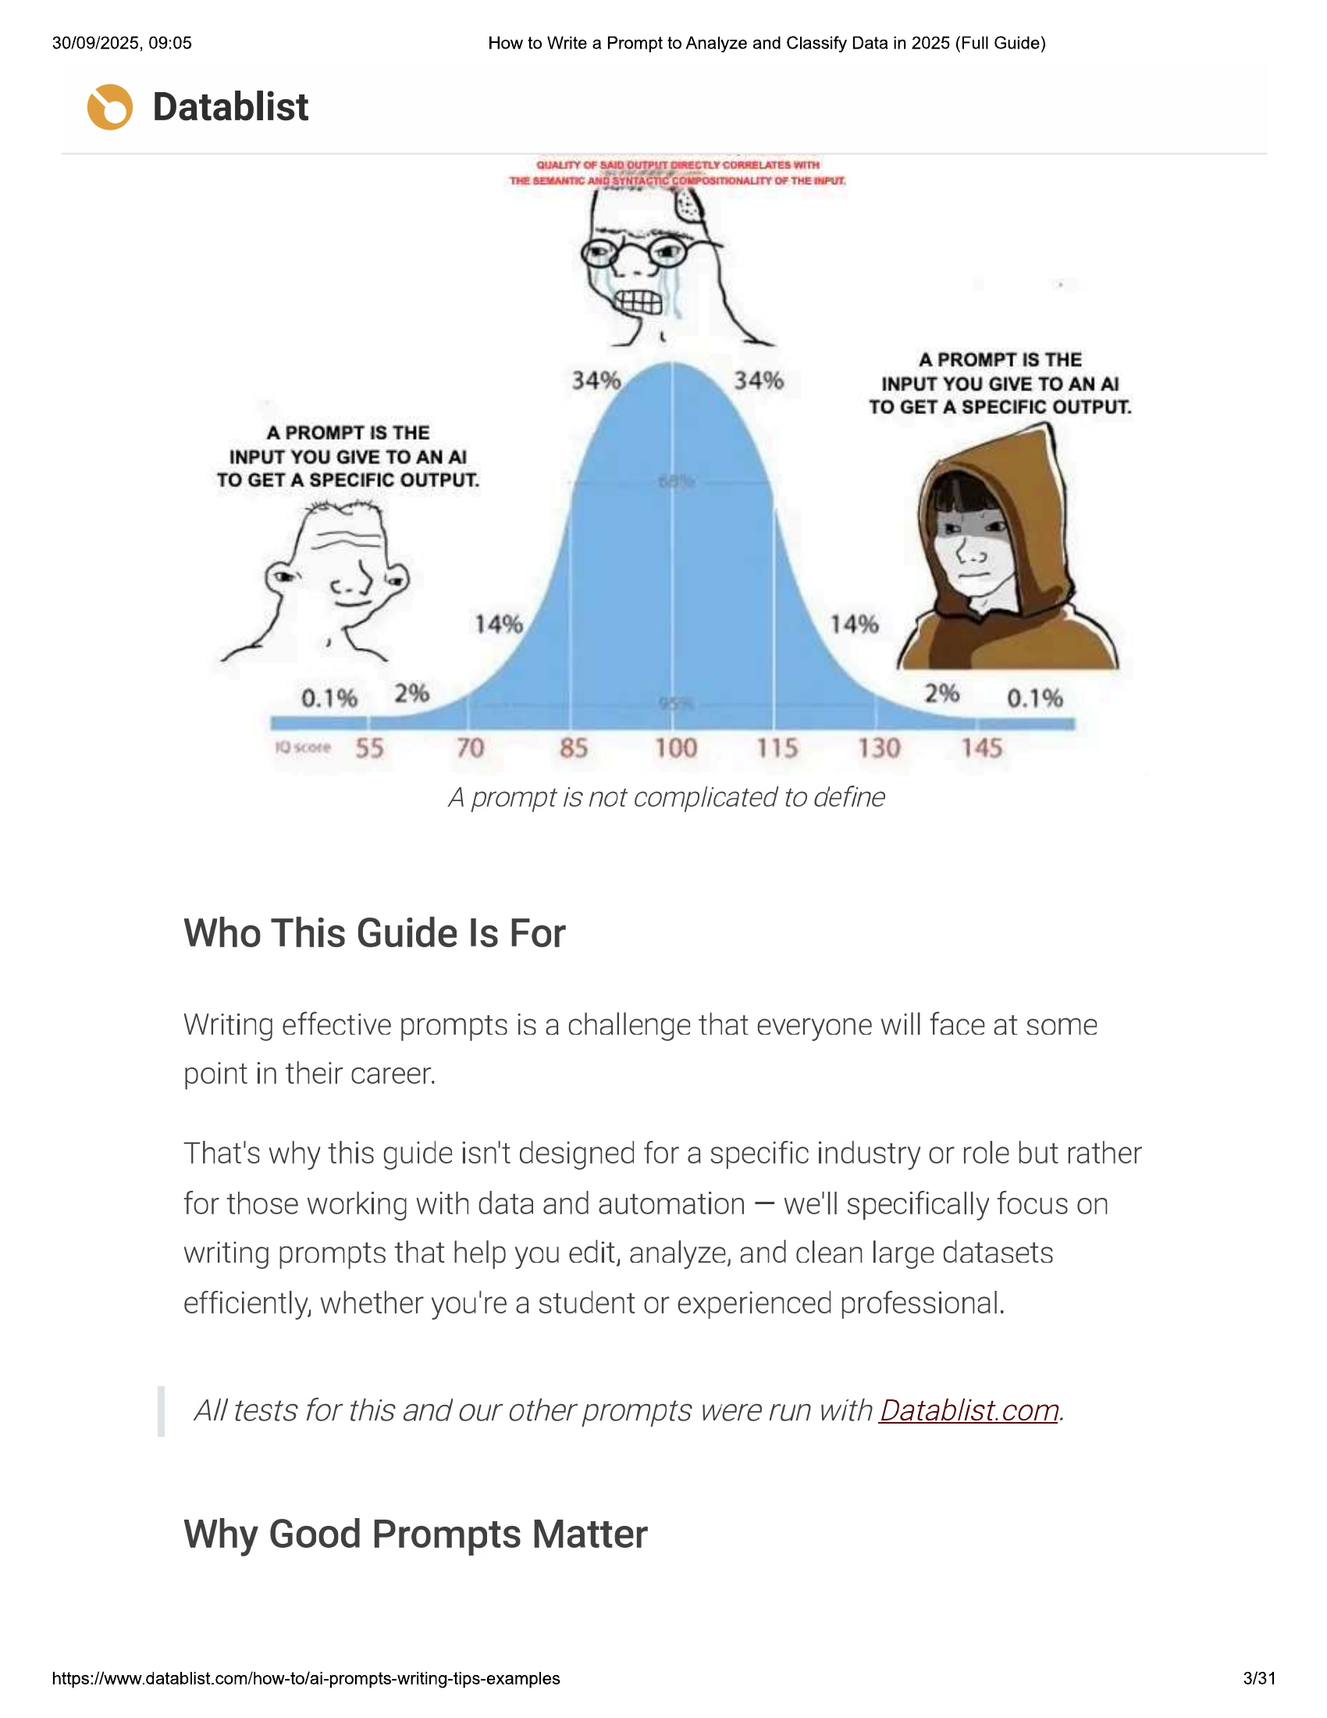

30/09/2025, 09:05 How to Write a Prompt to Analyze and Classify Data in 2025 (Full Guide)  
  
© Datablist  
  
A PROMPT IS THE  
34% INPUT YOU GIVE TO AN Al  
TO GET A SPECIFIC OUTPUT.  
  
A PROMPT IS THE  
INPUT YOU GIVE TO AN Al  
TO GET A SPECIFIC OUTPUT.  
  
Wxe 55 70 85 100 15 130 145  
  
A prompt is not complicated to define  
  
Who This Guide Is For  
  
Writing effective prompts is a challenge that everyone will face at some  
point in their career.  
  
That's why this guide isn't designed for a specific industry or role but rather  
for those working with data and automation — we'll specifically focus on  
writing prompts that help you edit, analyze, and clean large datasets  
efficiently, whether you're a student or experienced professional.  
  
All tests for this and our other prompts were run with Datablist.com.  
  
Why Good Prompts Matter  
  
https://www.datablist.com/how-to/ai-prompts-writing-tips-examples

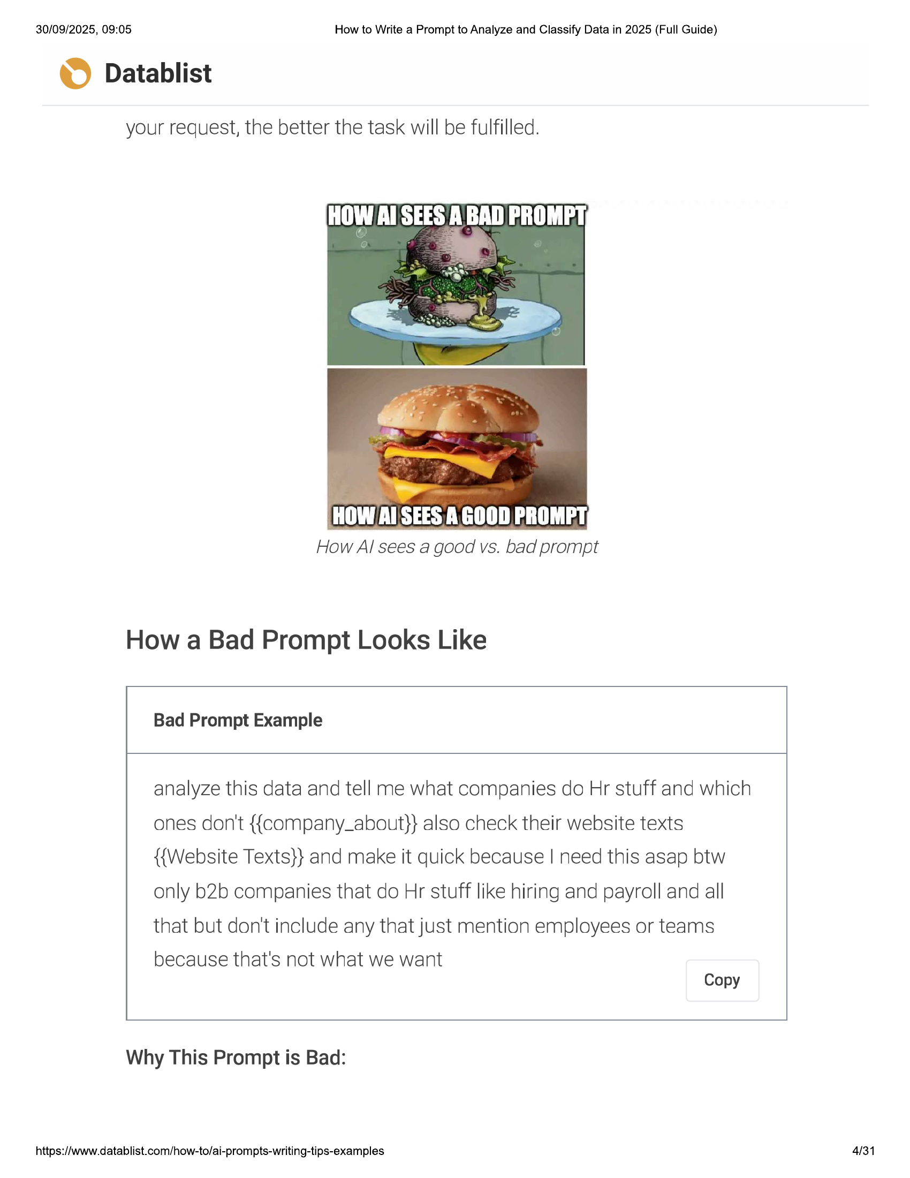

30/09/2025, 09:05 How to Write a Prompt to Analyze and Classify Data in 2025 (Full Guide)  
  
© Datablist  
  
your request, the better the task will be fulfilled.  
  
HOW Al SEES A.GOOD PROMPT,  
  
How Al sees a good vs. bad prompt  
  
How a Bad Prompt Looks Like  
  
Bad Prompt Example  
  
analyze this data and tell me what companies do Hr stuff and which  
ones don't {{company_about}} also check their website texts  
{{Website Texts}} and make it quick because | need this asap btw  
only b2b companies that do Hr stuff like hiring and payroll and all  
that but don't include any that just mention employees or teams  
  
because that's not what we want  
Copy  
  
Why This Prompt is Bad:  
  
https://www.datablist.com/how-to/ai-prompts-writing-tips-examples  
  
4/31

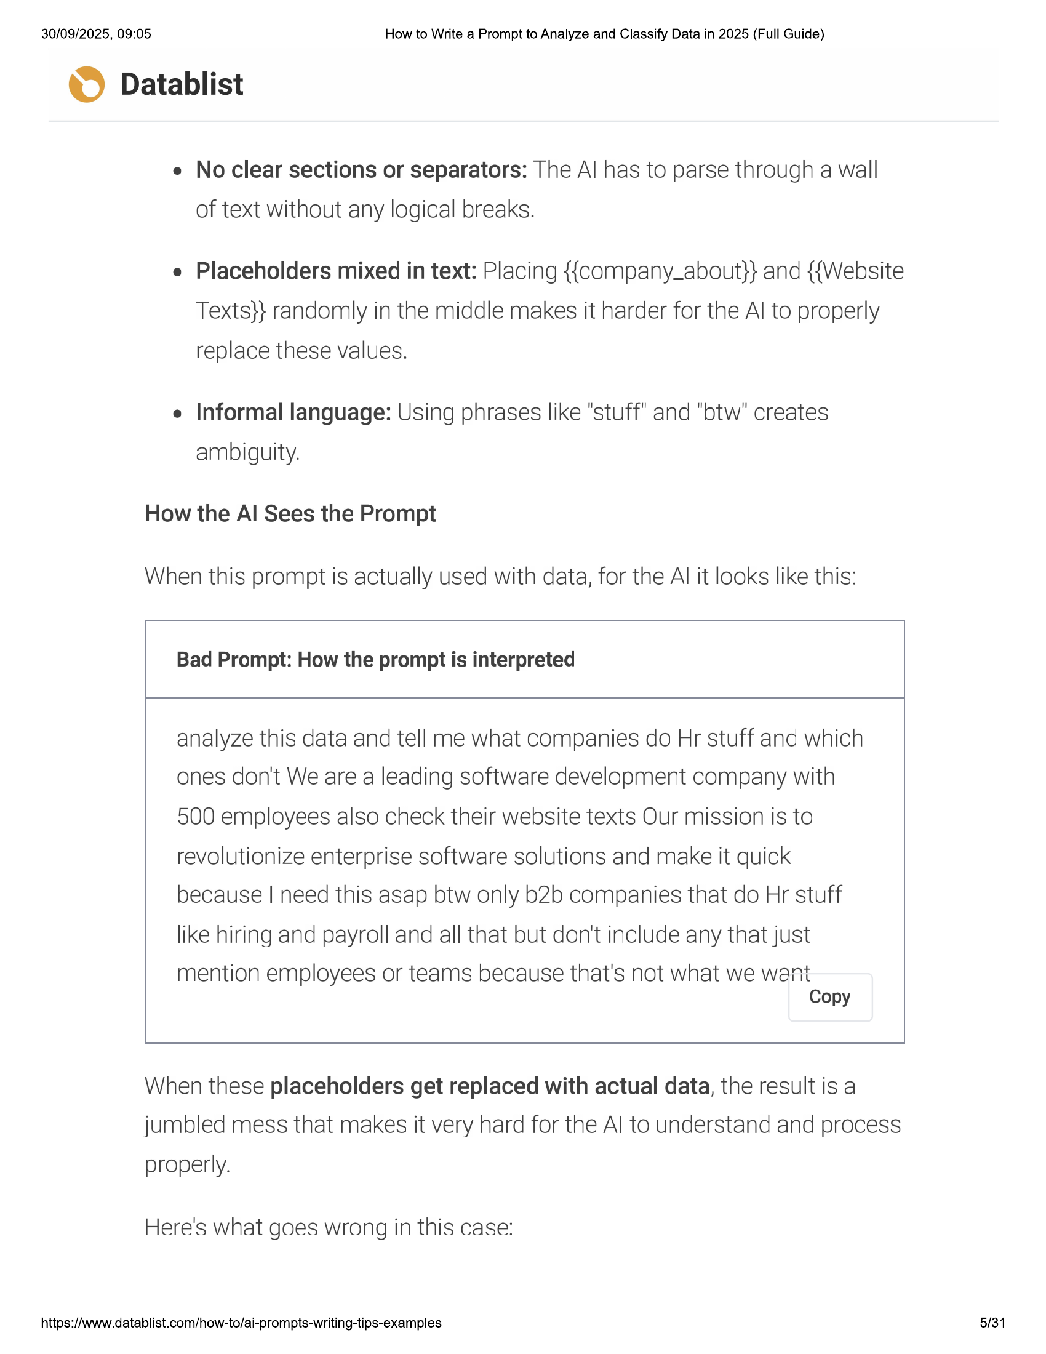

30/09/2025, 09:05 How to Write a Prompt to Analyze and Classify Data in 2025 (Full Guide)  
  
© Datablist  
e Noclear sections or separators: The Al has to parse through a wall  
of text without any logical breaks.  
  
e Placeholders mixed in text: Placing {{company_about}} and {{Website  
Texts}} randomly in the middle makes it harder for the Al to properly  
replace these values.  
  
e Informal language: Using phrases like "stuff" and "btw" creates  
ambiguity.  
  
How the Al Sees the Prompt  
  
When this prompt is actually used with data, for the Al it looks like this:  
  
Bad Prompt: How the prompt is interpreted  
  
analyze this data and tell me what companies do Hr stuff and which  
ones don't We are a leading software development company with  
500 employees also check their website texts Our mission is to  
revolutionize enterprise software solutions and make it quick  
because | need this asap btw only b2b companies that do Hr stuff  
like hiring and payroll and all that but don't include any that just  
  
mention employees or teams because that's not what we want  
Copy  
  
When these placeholders get replaced with actual data, the result is a  
jumbled mess that makes it very hard for the Al to understand and process  
  
properly.  
  
Here's what goes wrong in this case:  
  
https://www.datablist.com/how-to/ai-prompts-writing-tips-examples  
  
5/31

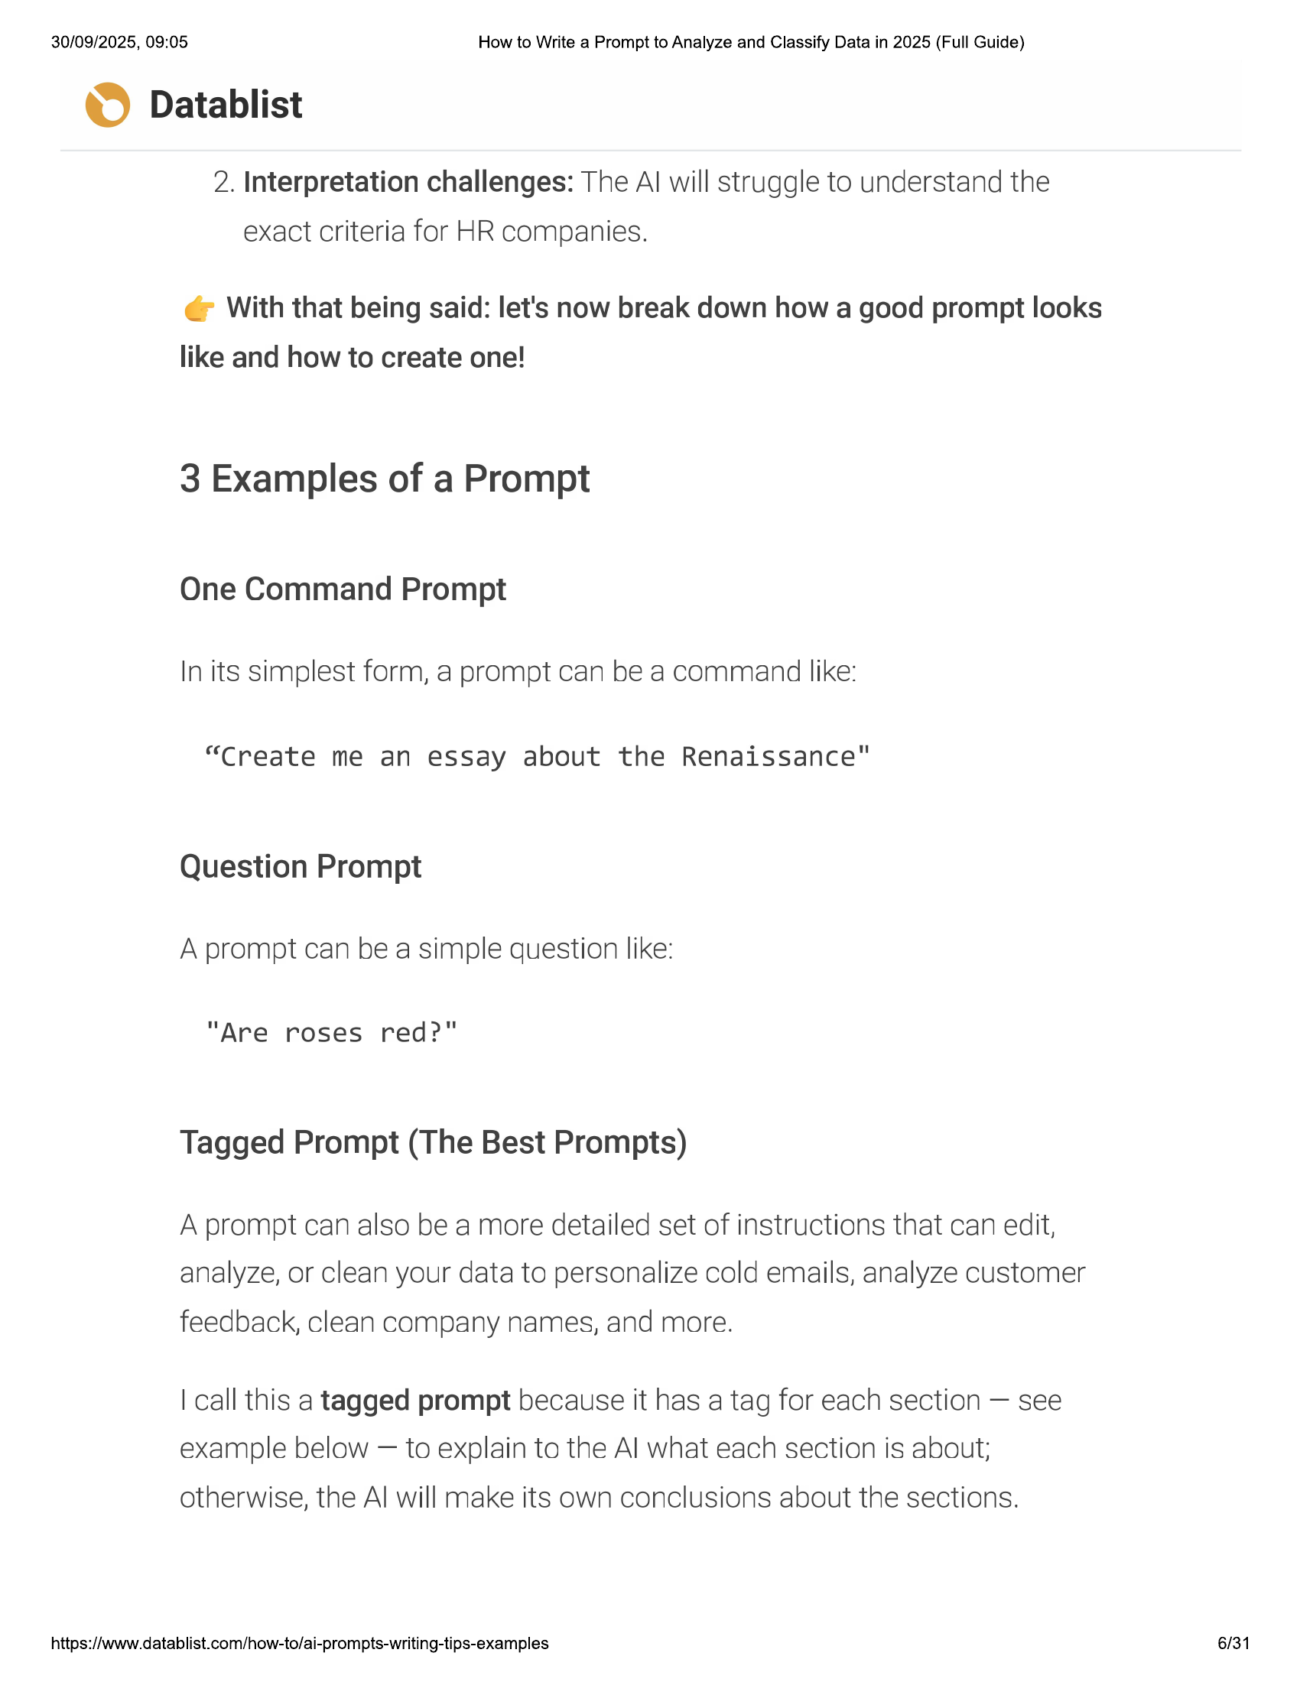

30/09/2025, 09:05 How to Write a Prompt to Analyze and Classify Data in 2025 (Full Guide)  
© Datablist  
  
2. Interpretation challenges: The Al will struggle to understand the  
exact criteria for HR companies.  
  
© With that being said: let's now break down how a good prompt looks  
like and how to create one!  
  
3 Examples of a Prompt  
  
One Command Prompt  
In its simplest form, a prompt can be a command like:  
  
“Create me an essay about the Renaissance"  
  
Question Prompt  
A prompt can be a simple question like:  
  
"Are roses red?"  
  
Tagged Prompt (The Best Prompts)  
  
A prompt can also be a more detailed set of instructions that can edit,  
analyze, or clean your data to personalize cold emails, analyze customer  
  
feedback, clean company names, and more.  
  
| call this a tagged prompt because it has a tag for each section — see  
example below — to explain to the Al what each section is about;  
otherwise, the Al will make its own conclusions about the sections.  
  
https://www.datablist.com/how-to/ai-prompts-writing-tips-examples 6/31

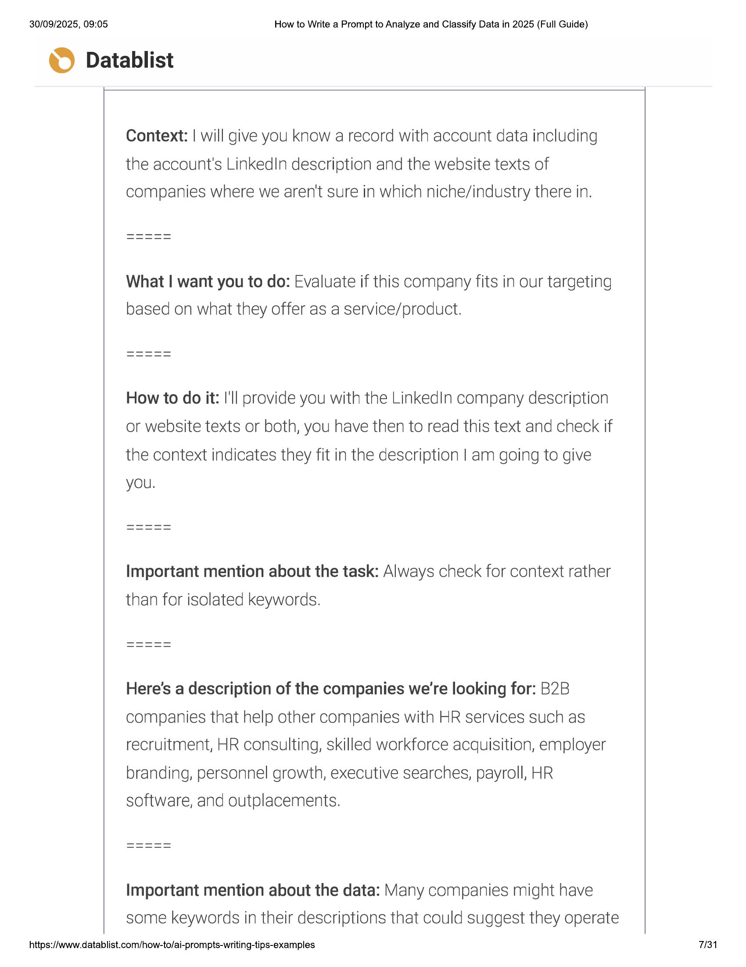

30/09/2025, 09:05 How to Write a Prompt to Analyze and Classify Data in 2025 (Full Guide)  
  
© Datablist  
  
Context: | will give you know a record with account data including  
the account's LinkedIn description and the website texts of  
companies where we aren't Sure in which niche/industry there in.  
  
What | want you to do: Evaluate if this company fits in our targeting  
based on what they offer as a service/product.  
  
How to do it: I'll provide you with the LinkedIn company description  
or website texts or both, you have then to read this text and check if  
the context indicates they fit in the description | am going to give  
yOu.  
  
Important mention about the task: Always check for context rather  
than for isolated keywords.  
  
Here's a description of the companies we're looking for: B2B  
companies that help other companies with HR services such as  
recruitment, HR consulting, skilled workforce acquisition, employer  
branding, personnel growth, executive searches, payroll, HR  
software, and outplacements.  
  
Important mention about the data: Many companies might have  
  
some keywords in their descriptions that could suggest they operate  
  
https://www.datablist.com/how-to/ai-prompts-writing-tips-examples 7/31

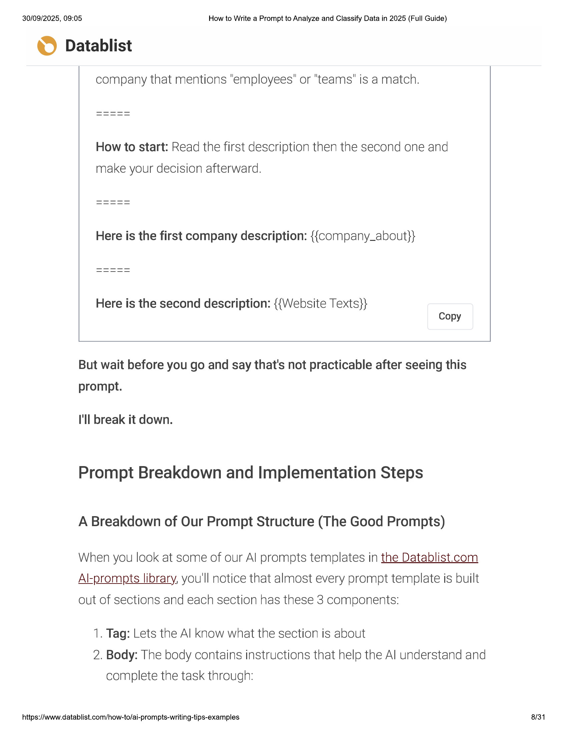

30/09/2025, 09:05 How to Write a Prompt to Analyze and Classify Data in 2025 (Full Guide)  
© Datablist  
  
company that mentions "employees" or "teams" is a match.  
  
How to start: Read the first description then the second one and  
make your decision afterward.  
  
Here is the second description: {{Website Texts}}  
Copy  
  
But wait before you go and say that's not practicable after seeing this  
prompt.  
  
I'll break it down.  
  
Prompt Breakdown and Implementation Steps  
  
A Breakdown of Our Prompt Structure (The Good Prompts)  
  
When you look at some of our Al prompts templates in the Datablist.com  
Akprompts library, you'll notice that almost every prompt template is built  
  
out of sections and each section has these 3 components:  
  
1. Tag: Lets the Al know what the section is about  
2. Body: The body contains instructions that help the Al understand and  
complete the task through:  
  
https://www.datablist.com/how-to/ai-prompts-writing-tips-examples 8/31

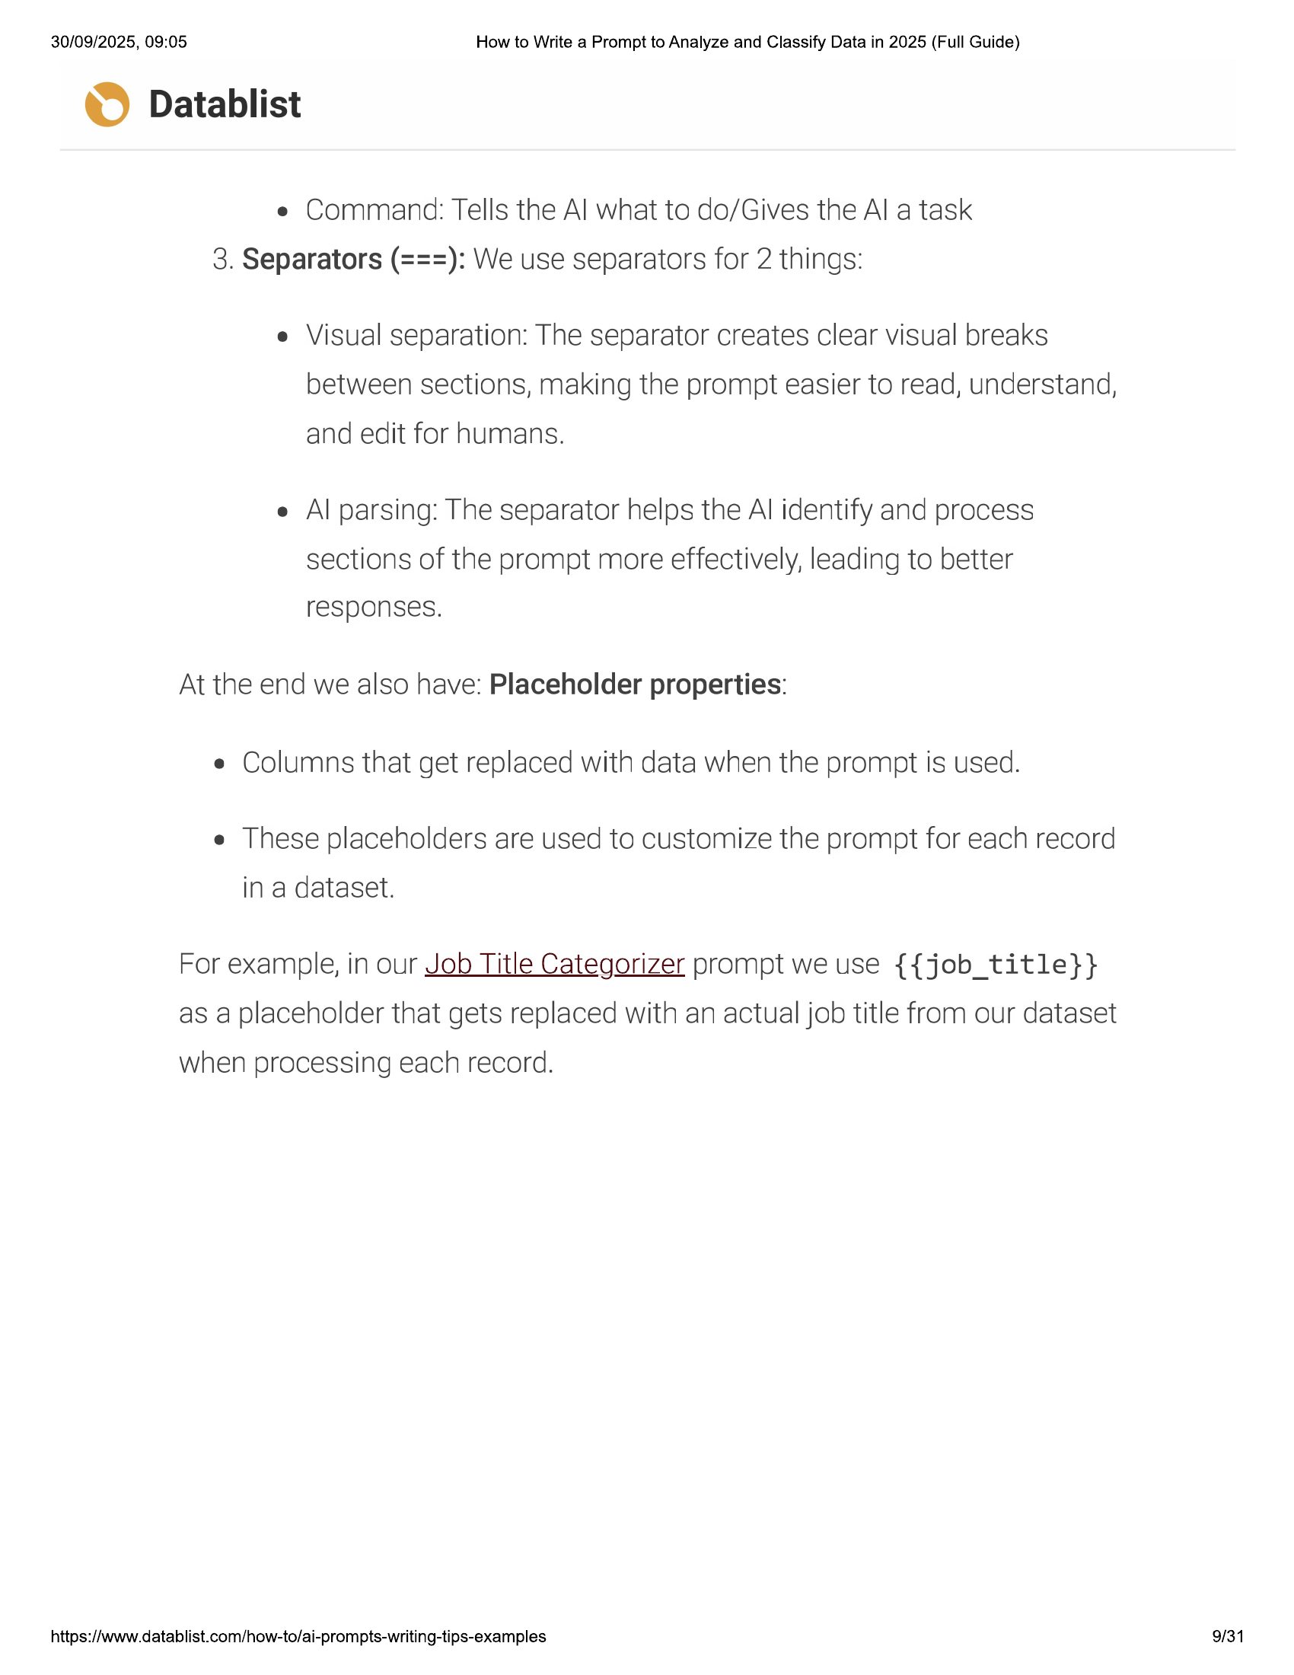

30/09/2025, 09:05 How to Write a Prompt to Analyze and Classify Data in 2025 (Full Guide)  
  
© Datablist  
e Command: Tells the Al what to do/Gives the Al a task  
3. Separators (===): We use separators for 2 things:  
  
e Visual separation: The separator creates clear visual breaks  
between sections, making the prompt easier to read, understand,  
and edit for humans.  
  
e Al parsing: The separator helps the Al identify and process  
sections of the prompt more effectively, leading to better  
responses.  
  
At the end we also have: Placeholder properties:  
e Columns that get replaced with data when the prompt is used.  
  
e These placeholders are used to customize the prompt for each record  
in a dataset.  
  
For example, in our Job Title Categorizer prompt we use {{job_title}}  
  
as a placeholder that gets replaced with an actual job title from our dataset  
when processing each record.  
  
https://www.datablist.com/how-to/ai-prompts-writing-tips-examples  
  
9/31

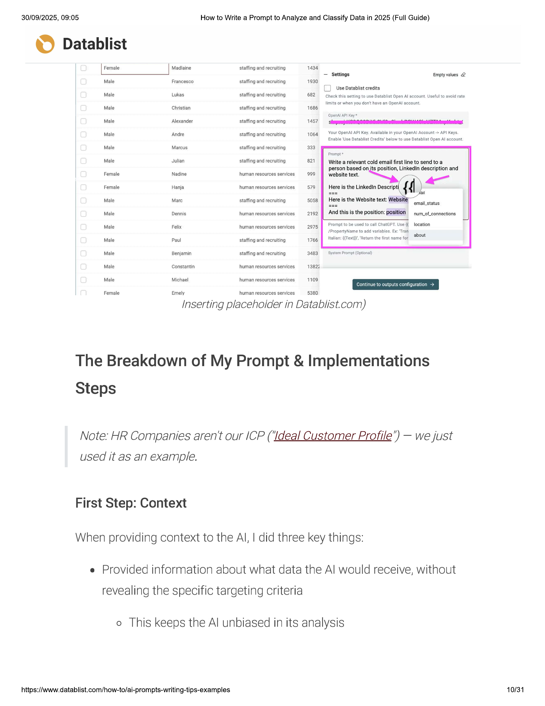

30/09/2025, 09:05 How to Write a Prompt to Analyze and Classify Data in 2025 (Full Guide)  
  
© Datablist  
Female Madlaine staffing and recruiting 1434  
— Settings  
  
Empty values  
Male Francesco staffing and recruiting 1930  
{_) Use Datablist credits  
Male Lukas staffing and recruiting 682 Check this setting to use Datablist Open Al account, Useful to avoid rate  
limits or when you don't have an OpenAl account.  
Male Christian staffing and recruiting 1686  
Openal API Key*  
Male Alexander staffing and recruiting 1457  
Male Rhihe staffing and recruiting 41064 Your Open API Key. Available in your Opendl Account -> API Keys.  
Enable 'Use Datablist Credits’ below to use Datablist Open Al account.  
Male Marcus staffing and recruiting 333  
Prompt *  
Male Julian staffing and recruiting 821 Write a relevant cold email first line to send to a  
person based on its position, LinkedIn description and  
Female Nadine human resources services 999 |! website text.  
Female Hanja human resources services 579 Here is the Linkedin Descripti { {  
al  
i is the Website text: Website —  
Male Mare staffing and recruiting 5058 emailistatie  
Male Dennis human resources services 2192 || And this is the position: position ,um_of_connections  
ile Felix human resources services 2975 | Prompt to be used to call ChatGPT. Use {{ location  
/PropertyName to add variables, Ex: "Tran  
‘i about  
Male Paul staifing end recruiting 1766 | Utalian: ({Text)}, ‘Return the first name for  
Male Benjamin staffing and recruiting 3483 System Prompt (Optional)  
Male Constantin human resources services 1382  
Male Michael human resources services 1109  
Continue to outputs configuration >  
Female Emely human resources services 5380  
  
Inserting placeholder in Datablist.com)  
  
The Breakdown of My Prompt & Implementations  
Steps  
  
Note: HR Companies aren't our ICP (‘Ideal Customer Profile’) — we just  
used it as an example.  
First Step: Context  
  
When providing context to the Al, | did three key things:  
  
e Provided information about what data the Al would receive, without  
revealing the specific targeting criteria  
  
o This keeps the Al unbiased in its analysis  
  
https://www.datablist.com/how-to/ai-prompts-writing-tips-examples 10/31

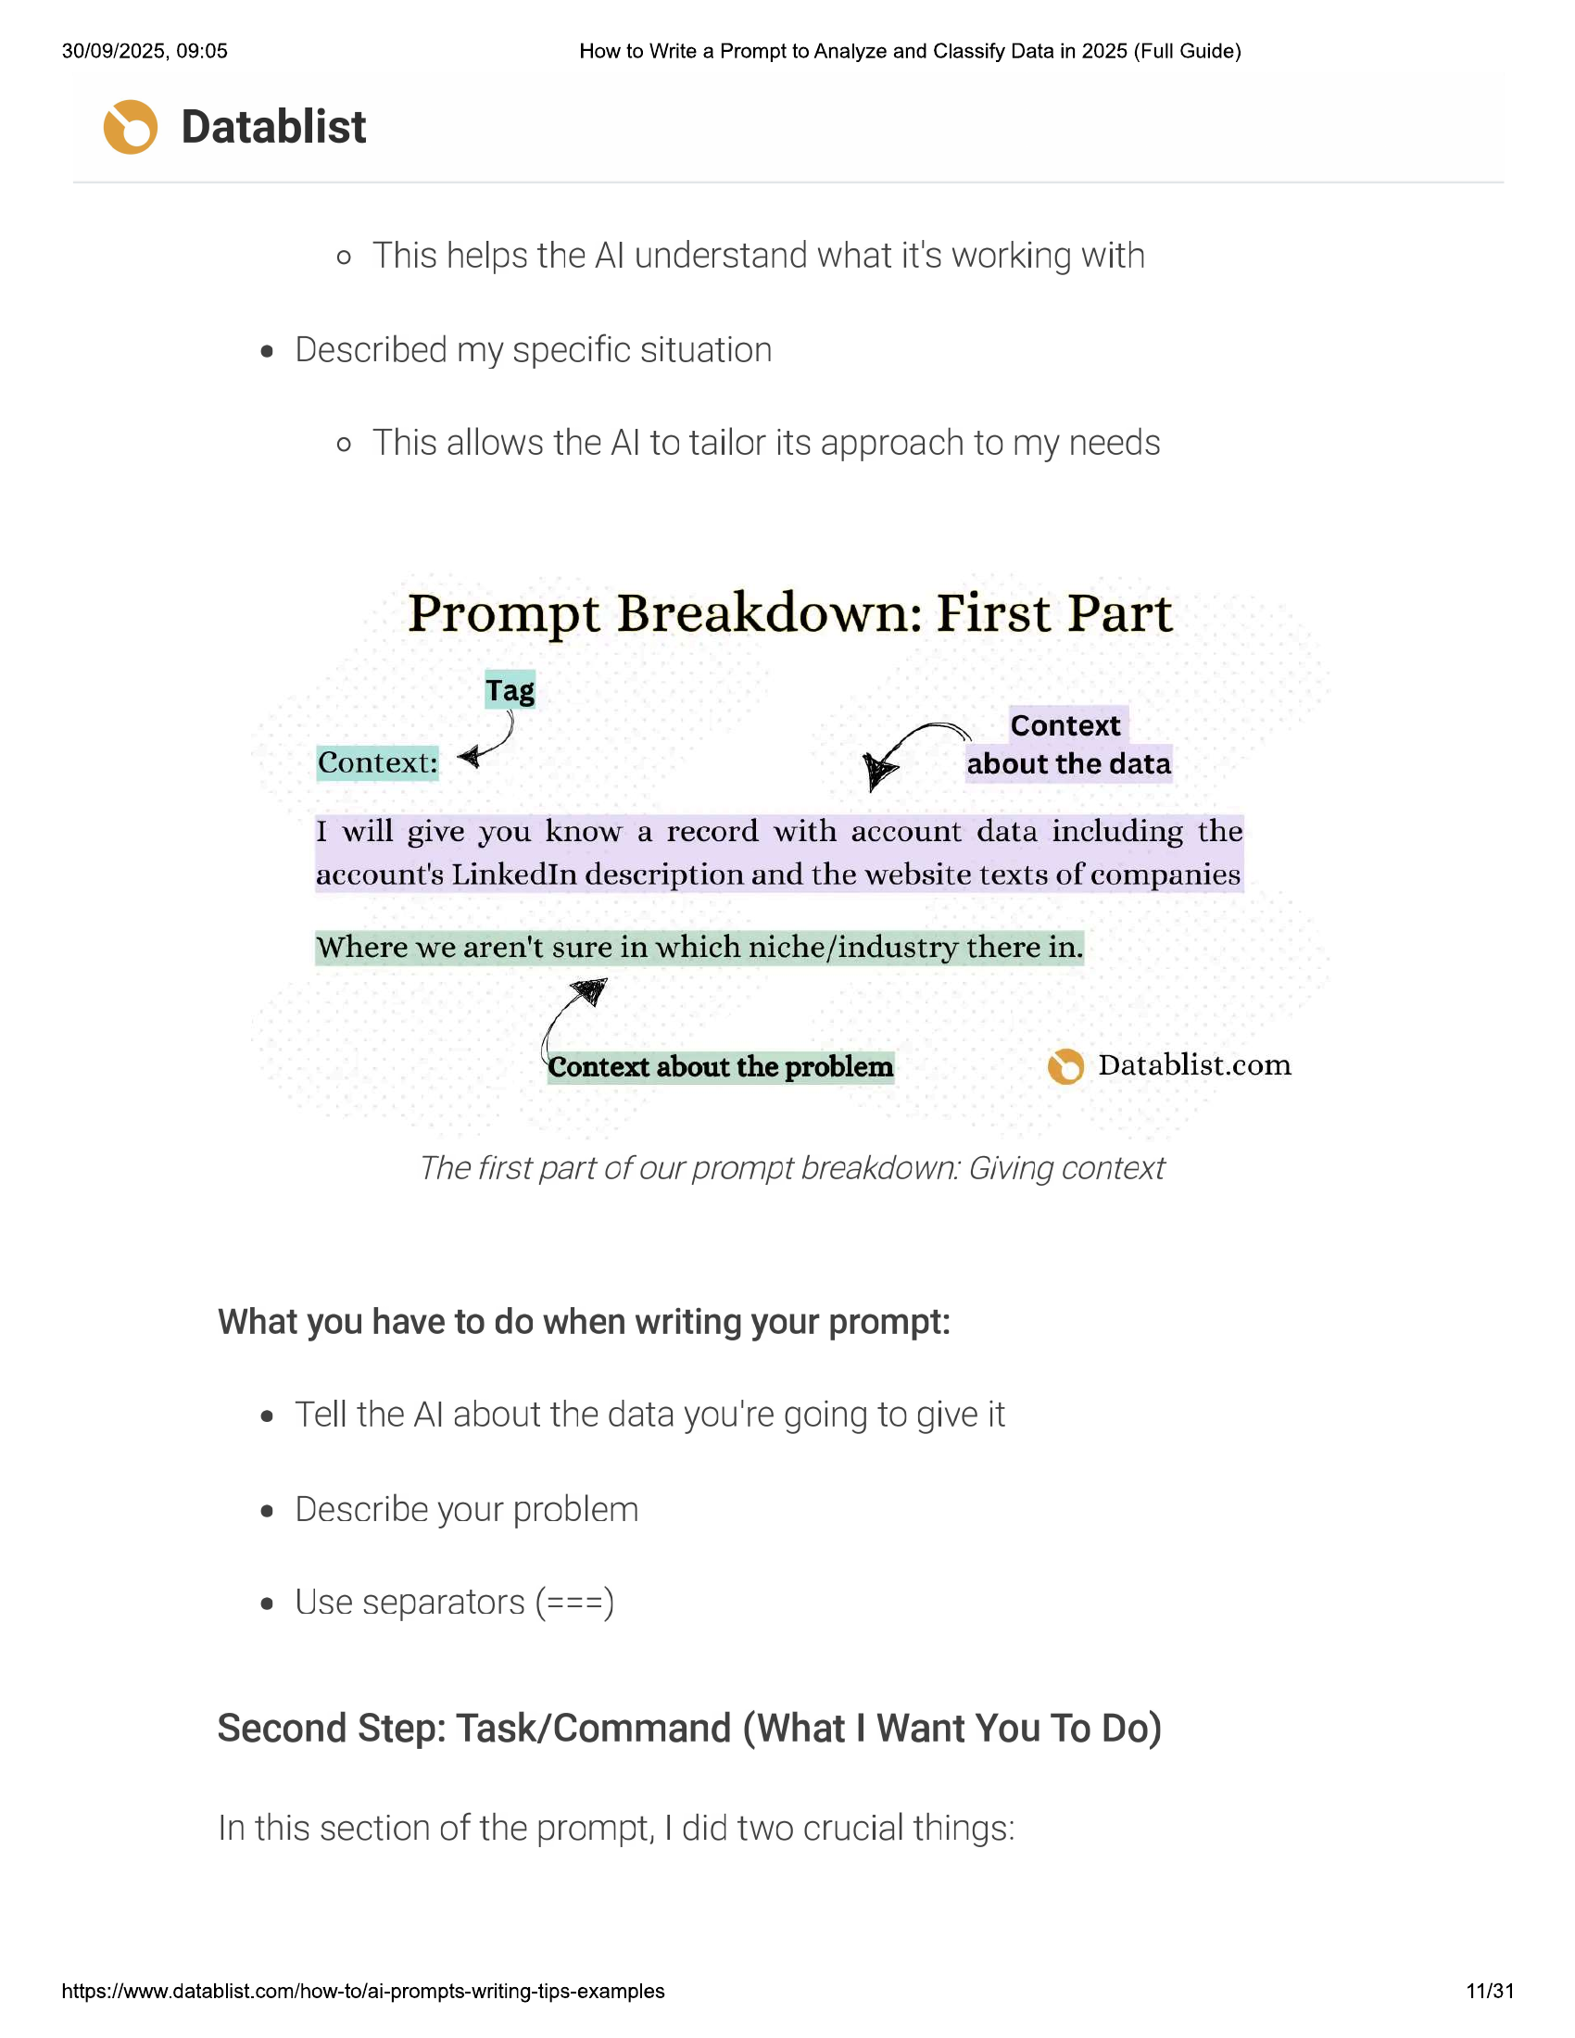

30/09/2025, 09:05 How to Write a Prompt to Analyze and Classify Data in 2025 (Full Guide)  
  
© Datablist  
  
o This helps the Al understand what it's working with  
  
e Described my specific situation  
  
© This allows the Al to tailor its approach to my needs  
  
Prompt Breakdown: First Part  
  
Tag  
  
ge Context  
Context: yi about the data  
  
I will give you know a record with account data including the  
account's LinkedIn description and the website texts of companies  
  
Where we aren't sure in which niche/industry there in.  
  
C. about the problem © Datablist.com  
  
The first part of our prompt breakdown: Giving context  
  
What you have to do when writing your prompt:  
e Tell the Al about the data you're going to give it  
e Describe your problem  
  
e Use separators (===)  
  
Second Step: Task/Command (What | Want You To Do)  
  
In this section of the prompt, | did two crucial things:  
  
https://www.datablist.com/how-to/ai-prompts-writing-tips-examples 11/31

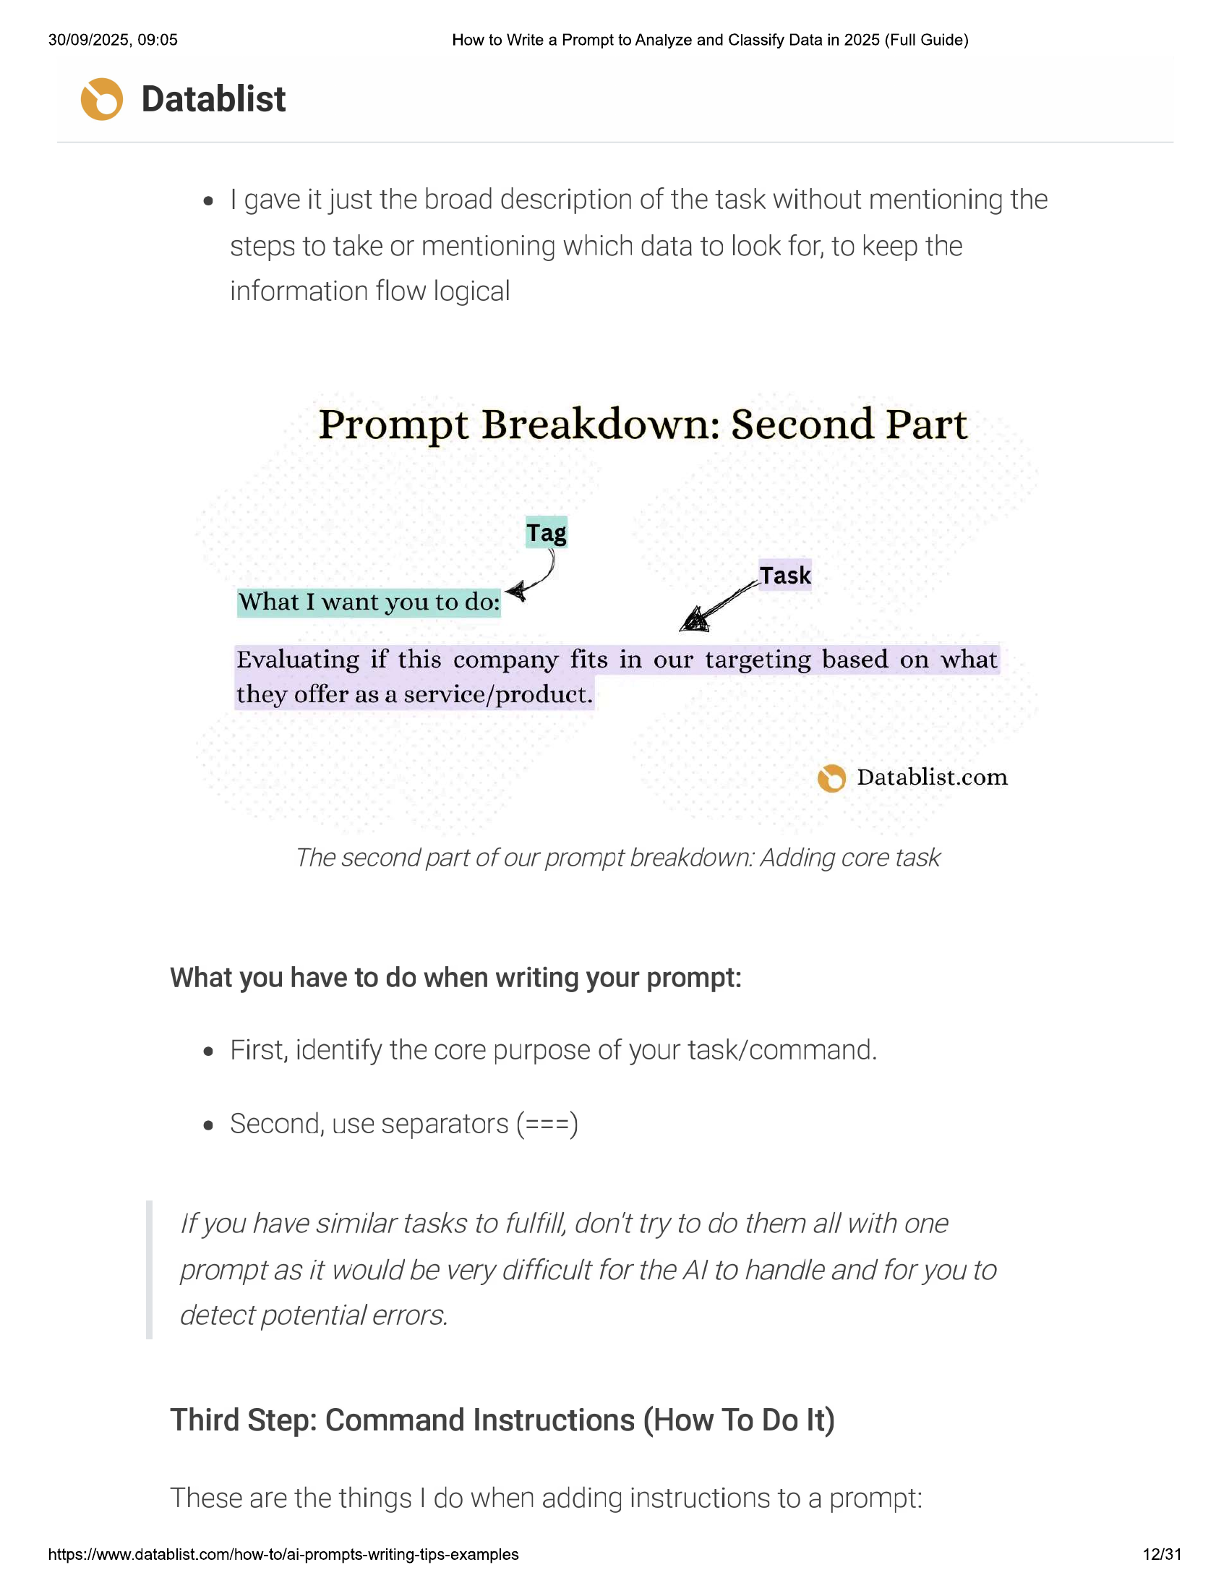

30/09/2025, 09:05 How to Write a Prompt to Analyze and Classify Data in 2025 (Full Guide)  
  
© Datablist  
  
e | gave it just the broad description of the task without mentioning the  
steps to take or mentioning which data to look for, to keep the  
information flow logical  
  
Prompt Breakdown: Second Part  
  
Tag  
Task  
  
What I want you to do: < “a  
  
Evaluating if this company fits in our targeting based on what  
they offer as a service/product.  
  
© Datablist.com  
  
The second part of our prompt breakdown. Adding core task  
  
What you have to do when writing your prompt:  
e First, identify the core purpose of your task/command.  
e Second, use separators (===)  
/f you have similar tasks to fulfill, don't try to do them all with one  
prompt as it would be very difficult for the Al to hanale and for you to  
detect potential errors.  
Third Step: Command Instructions (How To Do It)  
  
These are the things | do when adding instructions to a prompt:  
  
https://www.datablist.com/how-to/ai-prompts-writing-tips-examples 12/31

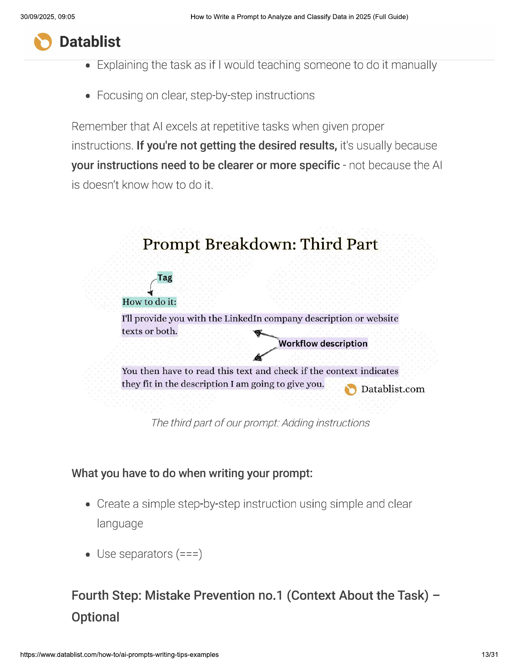

30/09/2025, 09:05 How to Write a Prompt to Analyze and Classify Data in 2025 (Full Guide)  
  
© Datablist  
  
e Explaining the task as if | would teaching someone to do it manually  
e Focusing on clear, step-by-step instructions  
  
Remember that Al excels at repetitive tasks when given proper  
instructions. If you're not getting the desired results, it's Usually because  
your instructions need to be clearer or more specific - not because the Al  
is doesn’t know how to do it.  
  
Prompt Breakdown: Third Part  
  
Tag  
  
How to do it:  
I'll provide you with the LinkedIn company description or website  
  
texts or both.  
Workflow description  
  
You then have to read this text and check if the context indicates  
they fit in the description I am going to give you. es) Datablist.com  
  
The third part of our prompt: Adding instructions  
  
What you have to do when writing your prompt:  
  
e Create a simple step-by-step instruction using simple and clear  
  
language  
  
e Use separators (===)  
  
Fourth Step: Mistake Prevention no.1 (Context About the Task) -  
Optional  
  
https://www.datablist.com/how-to/ai-prompts-writing-tips-examples  
  
13/31

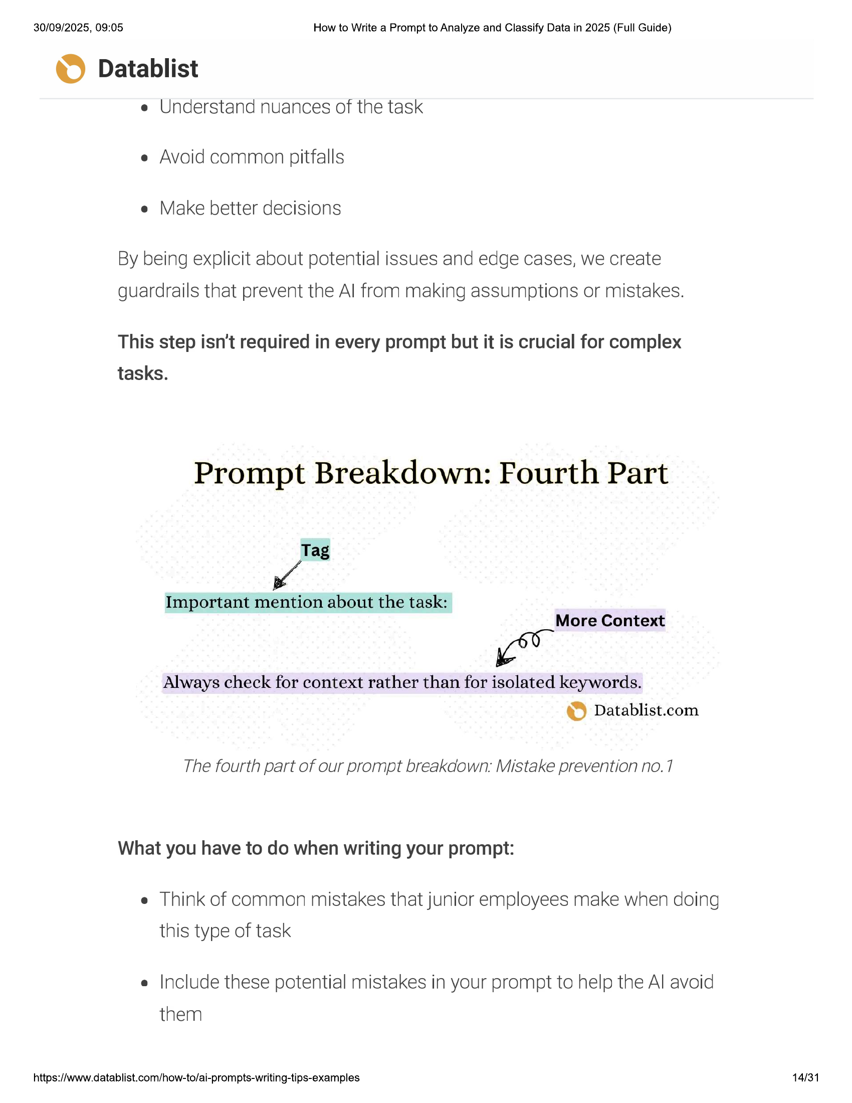

30/09/2025, 09:05 How to Write a Prompt to Analyze and Classify Data in 2025 (Full Guide)  
  
© Datablist  
  
e Understand nuances of the task  
e Avoid common pitfalls  
e Make better decisions  
  
By being explicit about potential issues and edge cases, we create  
guardrails that prevent the Al from making assumptions or mistakes.  
  
This step isn’t required in every prompt but it is crucial for complex  
  
tasks.  
  
Prompt Breakdown: Fourth Part  
  
Tag  
  
x  
  
Important mention about the task:  
More Context  
  
Always check for context rather than for isolated keywords.  
© Datablist.com  
  
The fourth part of our prompt breakdown: Mistake prevention no.7  
  
What you have to do when writing your prompt:  
  
e Think of common mistakes that junior employees make when doing  
this type of task  
  
e Include these potential mistakes in your prompt to help the Al avoid  
  
them  
  
https://www.datablist.com/how-to/ai-prompts-writing-tips-examples 14/31

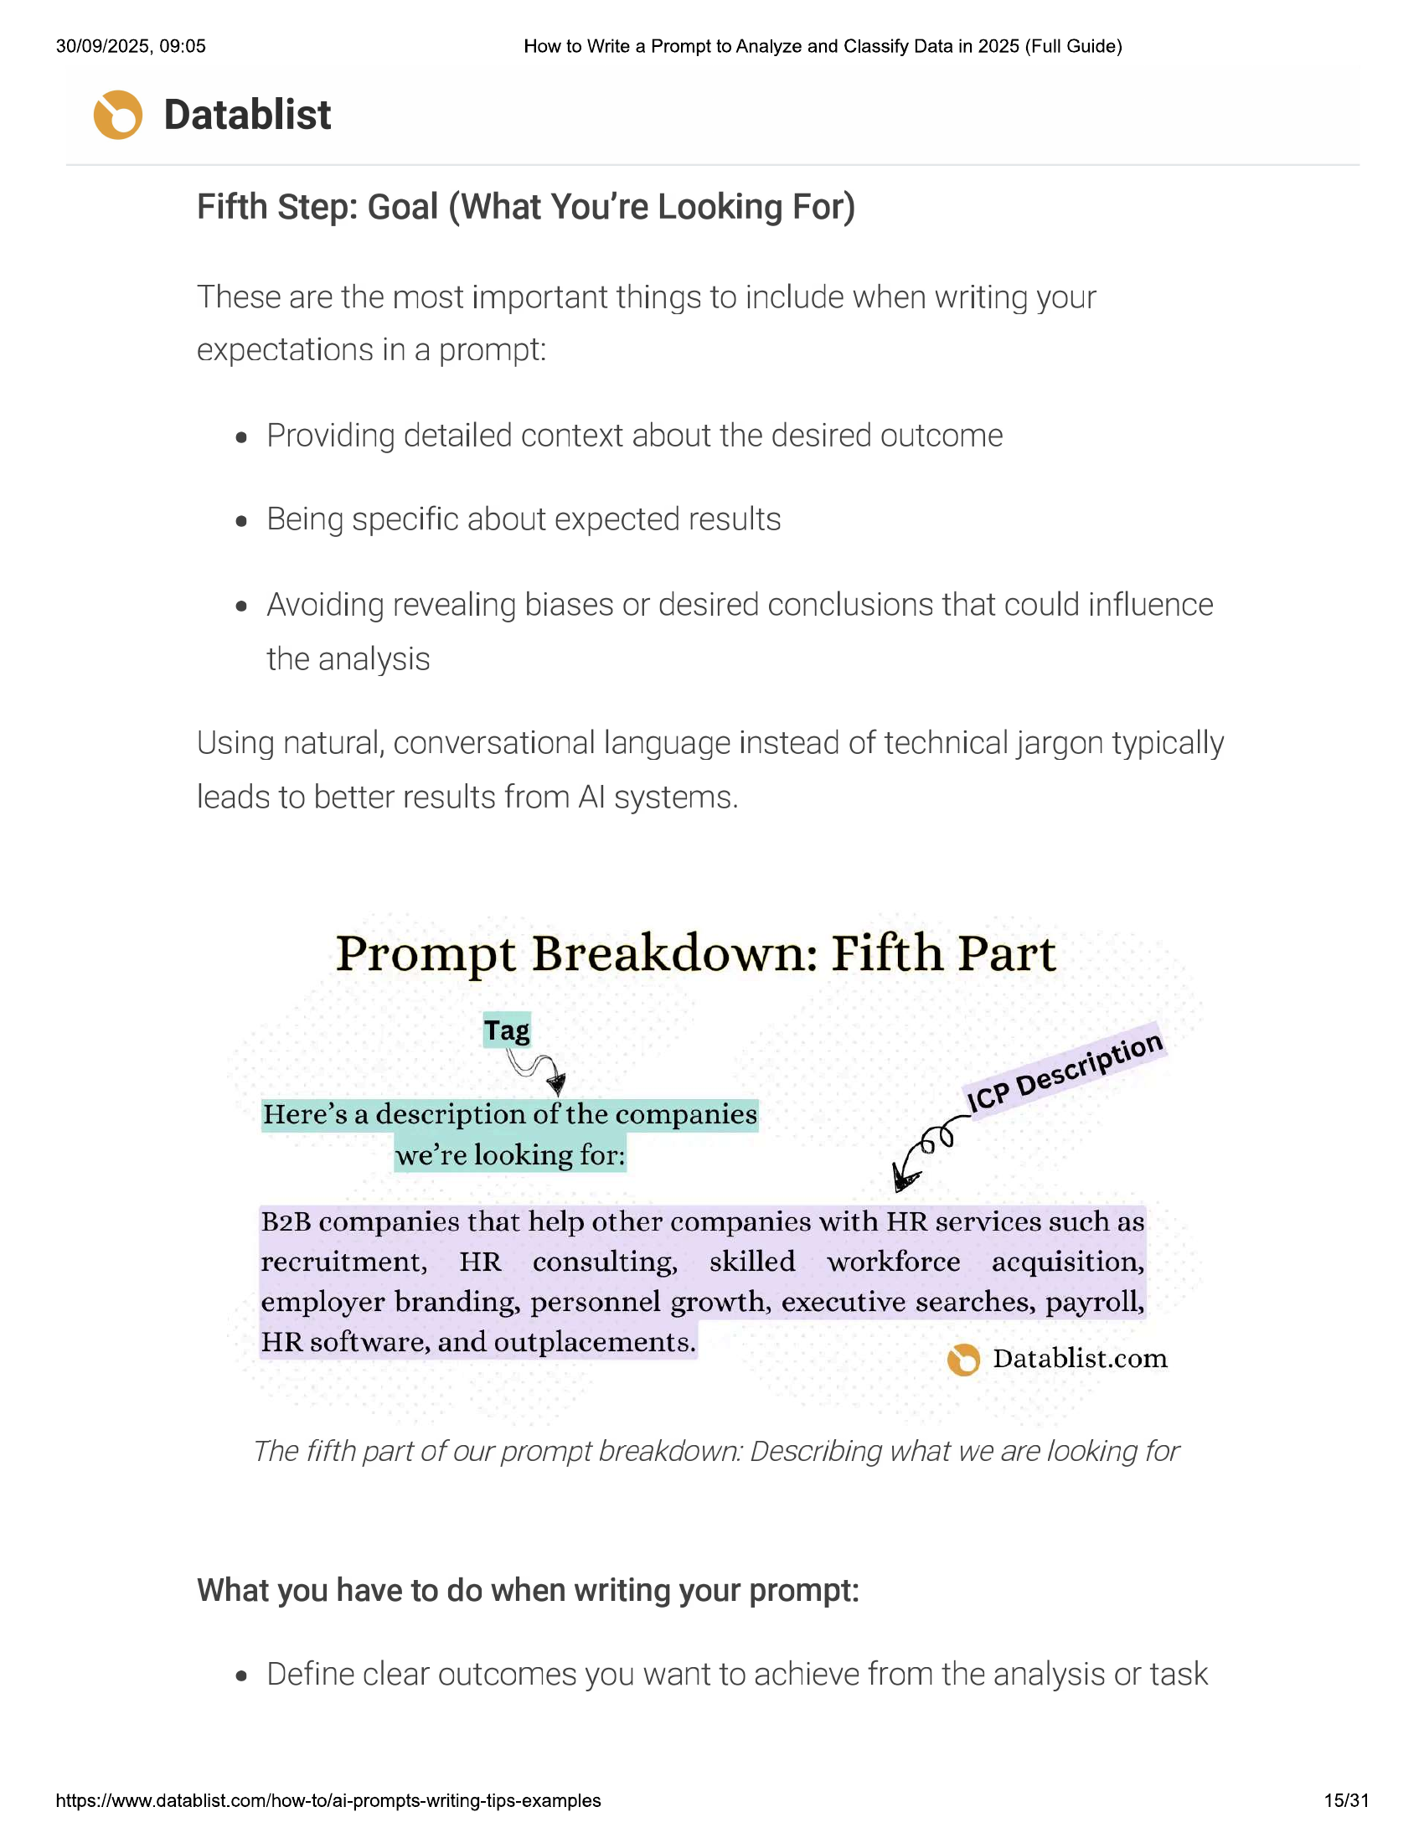

30/09/2025, 09:05 How to Write a Prompt to Analyze and Classify Data in 2025 (Full Guide)  
  
© Datablist  
Fifth Step: Goal (What You're Looking For)  
  
These are the most important things to include when writing your  
  
expectations in a prompt:  
e Providing detailed context about the desired outcome  
e Being specific about expected results  
  
e Avoiding revealing biases or desired conclusions that could influence  
  
the analysis  
  
Using natural, conversational language instead of technical jargon typically  
  
leads to better results from Al systems.  
  
Prompt Breakdown: Fifth Part  
  
Tag  
\  
& ct  
» eae YY = \c? ve  
Here’s a description of the companies  
  
we're looking for:  
  
AON.  
Ape  
  
B2B companies that help other companies with HR services such as  
recruitment, HR consulting, skilled workforce acquisition,  
employer branding, personnel growth, executive searches, payroll,  
HR software, and outplacements. Re) Datablish com  
  
The fifth part of our prompt breakdown: Describing what we are looking for  
  
What you have to do when writing your prompt:  
  
e Define clear outcomes you want to achieve from the analysis or task  
  
https://www.datablist.com/how-to/ai-prompts-writing-tips-examples 15/31

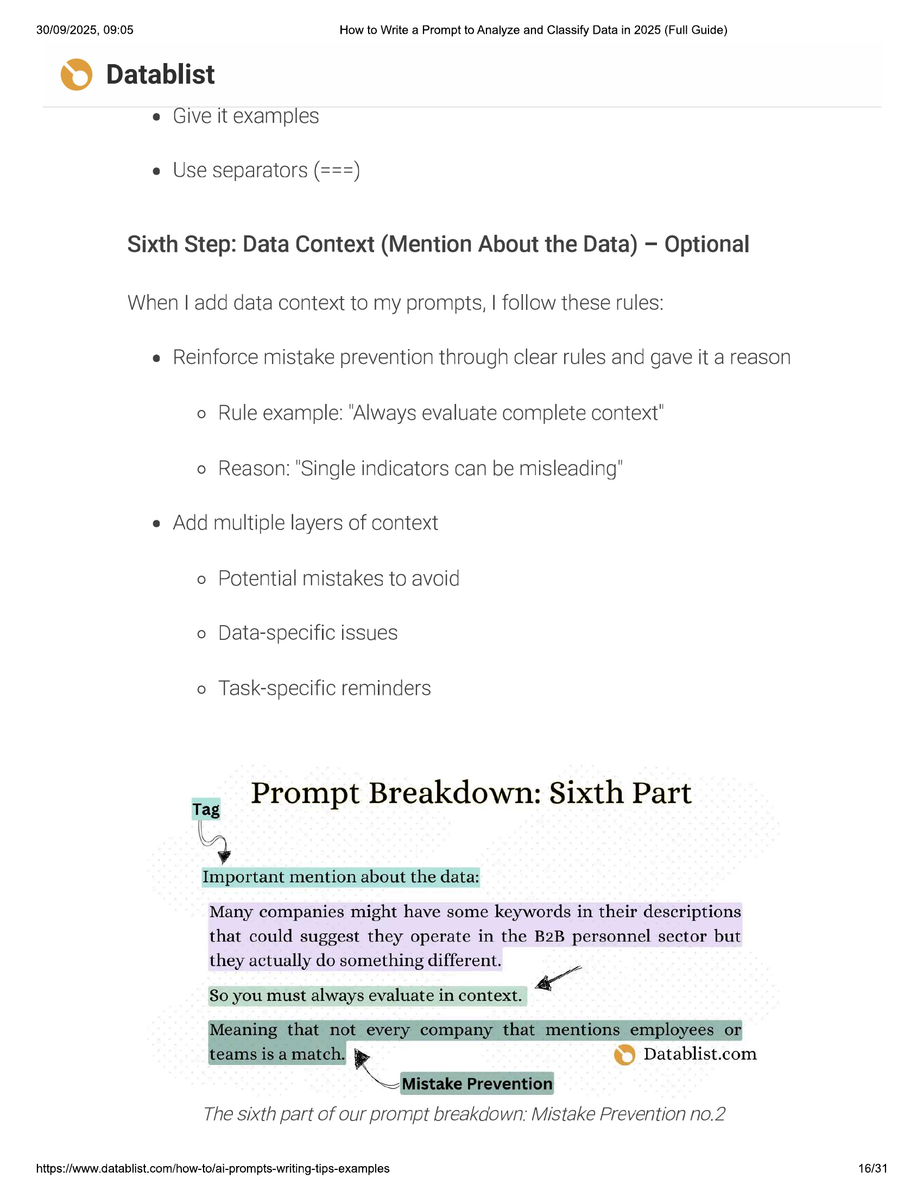

30/09/2025, 09:05  
  
How to Write a Prompt to Analyze and Classify Data in 2025 (Full Guide)  
  
© Datablist  
  
e Give it examples  
  
e Use separators (===)  
  
Sixth Step: Data Context (Mention About the Data) — Optional  
  
When | add data context to my prompts, | follow these rules:  
  
e Reinforce mistake prevention through clear rules and gave it a reason  
  
o Rule example: "Always evaluate complete context"  
  
o Reason: "Single indicators can be misleading"  
  
e Add multiple layers of context  
  
o Potential mistakes to avoid  
o Data-specific issues  
  
o Task-specific reminders  
  
tag PTOmpt Breakdown: Sixth Part  
  
4  
  
Important mention about the data:  
Many companies might have some keywords in their descriptions  
  
that could suggest they operate in the B2B personnel sector but  
they actually do something different.  
  
So you must always evaluate in context.  
  
ena oa © Datablist.com  
  
The sixth part of our prompt breakdown: Mistake Prevention no.2  
  
https://www.datablist.com/how-to/ai-prompts-writing-tips-examples  
  
16/31

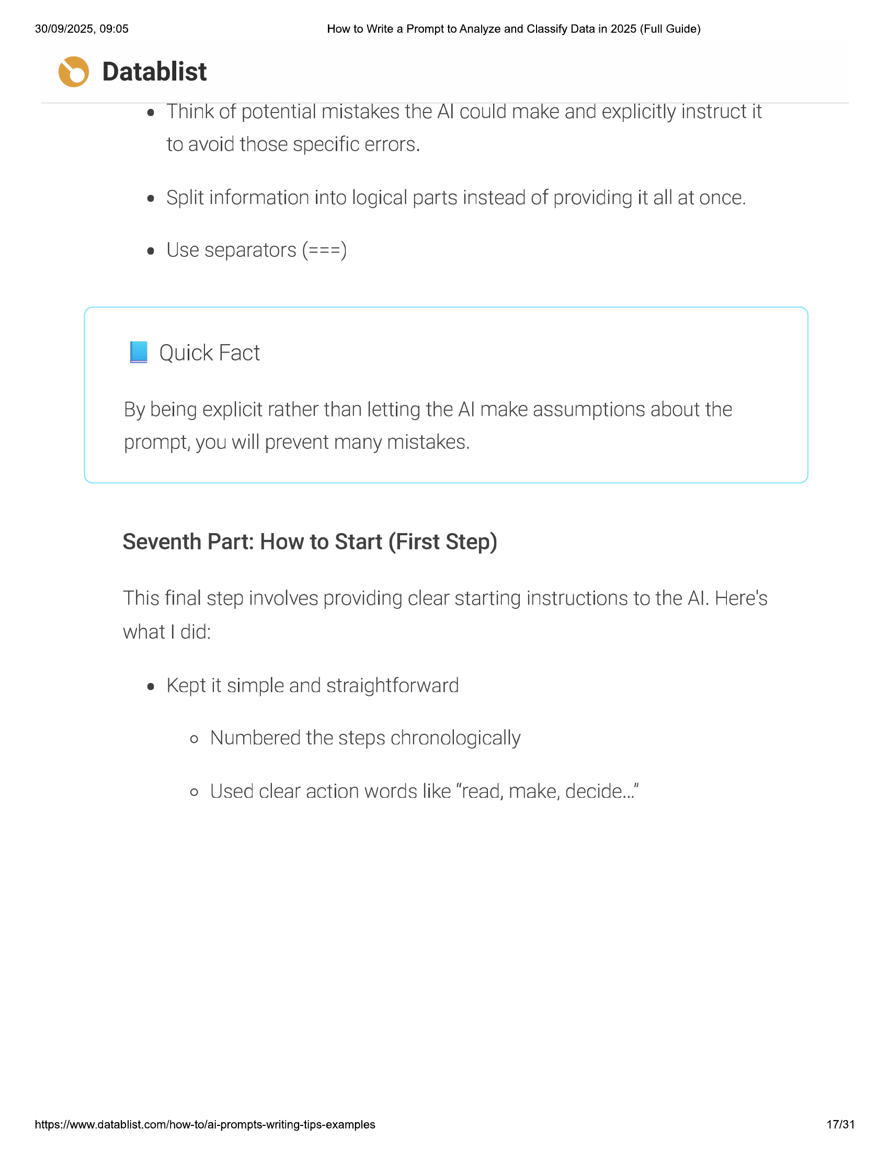

30/09/2025, 09:05 How to Write a Prompt to Analyze and Classify Data in 2025 (Full Guide)  
  
© Datablist  
e Think of potential mistakes the Al could make and explicitly instruct it  
to avoid those specific errors.  
  
e Split information into logical parts instead of providing it all at once.  
  
e Use separators (===)  
  
IB Quick Fact  
  
By being explicit rather than letting the Al make assumptions about the  
prompt, you will prevent many mistakes.  
  
Seventh Part: How to Start (First Step)  
  
This final step involves providing clear starting instructions to the Al. Here's  
what | did:  
  
e Kept it simple and straightforward  
o Numbered the steps chronologically  
  
o Used clear action words like “read, make, decide...”  
  
https://www.datablist.com/how-to/ai-prompts-writing-tips-examples 17/31

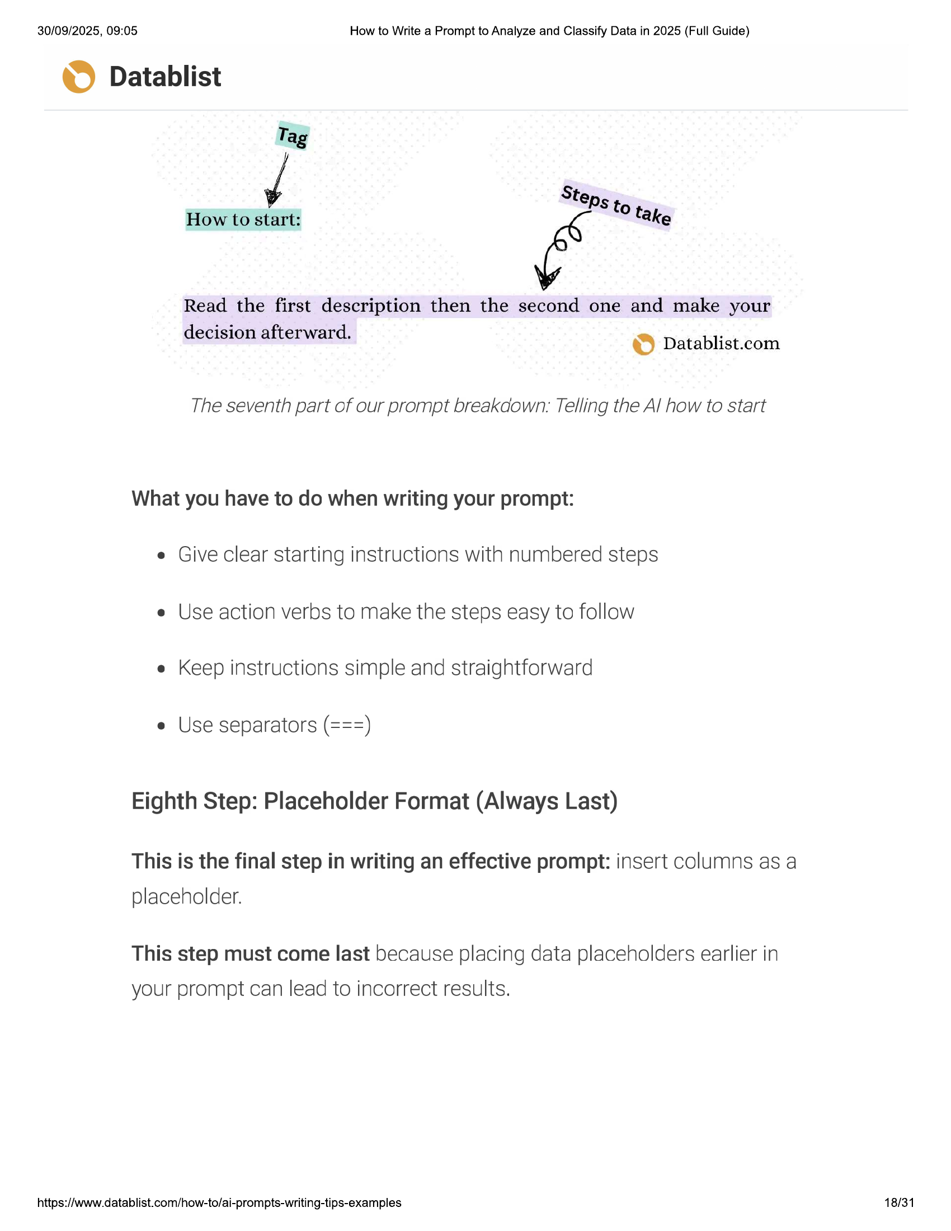

30/09/2025, 09:05 How to Write a Prompt to Analyze and Classify Data in 2025 (Full Guide)  
  
© Datablist  
  
Tag  
  
S  
J teps to ta ke  
  
How to start:  
  
Read the first description then the second one and make your  
  
decision afterward. © Datablist.com  
  
The seventh part of our prompt breakdown: Telling the Al how to start  
  
What you have to do when writing your prompt:  
e Give clear starting instructions with numbered steps  
e Use action verbs to make the steps easy to follow  
e Keep instructions simple and straightforward  
  
e Use separators (===)  
  
Eighth Step: Placeholder Format (Always Last)  
  
This is the final step in writing an effective prompt: insert columns as a  
placeholder.  
  
This step must come last because placing data placeholders earlier in  
  
your prompt can lead to incorrect results.  
  
https://www.datablist.com/how-to/ai-prompts-writing-tips-examples 18/31

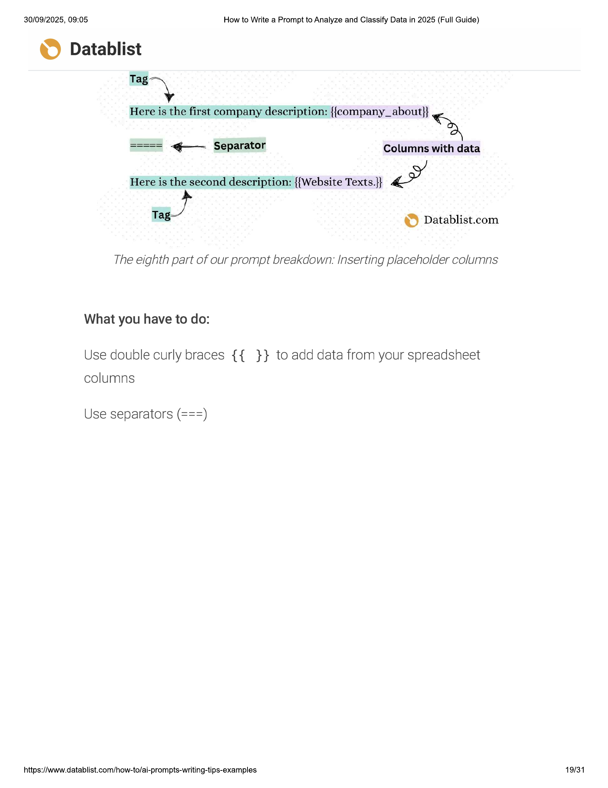

30/09/2025, 09:05 How to Write a Prompt to Analyze and Classify Data in 2025 (Full Guide)  
  
© Datablist  
  
ie  
  
Here is the first company description: {{company_about}} >  
===== <—- Separator Columns with data  
Here is the second description: {{Website Texts.}} FEA  
  
Tag. © Datablist.com  
  
The eighth part of our prompt breakdown. Inserting placeholder columns  
  
What you have to do:  
  
Use double curly braces {{ }} to add data from your spreadsheet  
columns  
  
Use separators (===)  
  
https://www.datablist.com/how-to/ai-prompts-writing-tips-examples 19/31

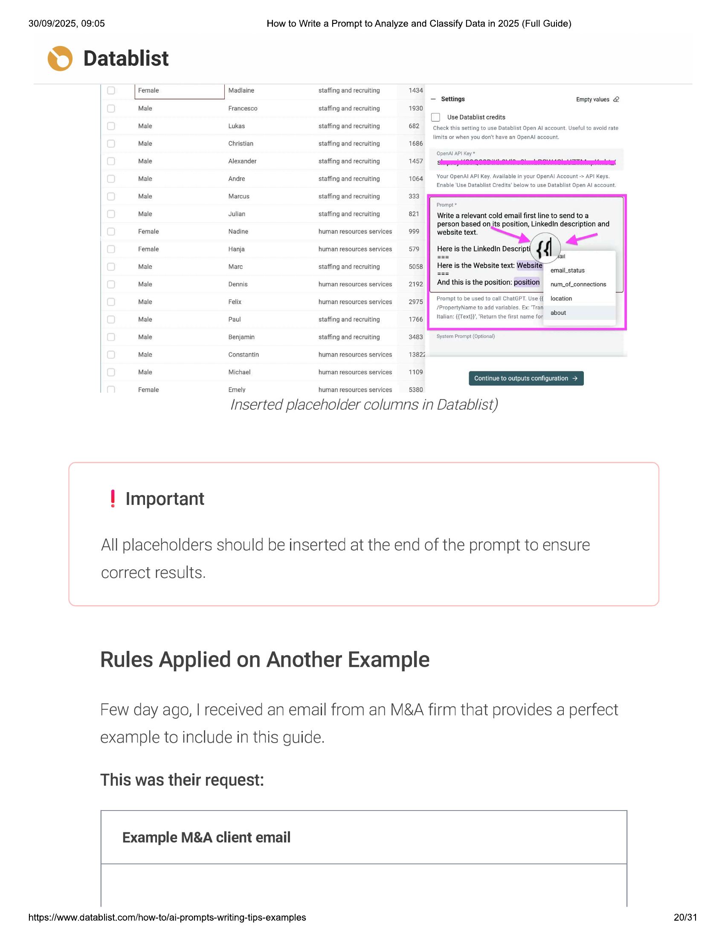

30/09/2025, 09:05 How to Write a Prompt to Analyze and Classify Data in 2025 (Full Guide)  
  
© Datablist  
Female Madlaine  
  
Male Francesco  
Male Lukas  
Male Christian  
Male Alexander  
Male Andre  
Male Marcus  
Male Julian  
Female Nadine  
Female Hanja  
Male Mare  
Male Dennis  
Male Felix  
Male Paul  
  
Male Benjamin  
Male Constantin  
Male Michael  
Female Emely  
  
staffing and recruiting  
staffing and recruiting  
staffing and recruiting  
staffing and recruiting  
staffing and recruiting  
staffing and recruiting  
staffing and recruiting  
staffing and recruiting  
human resources services  
human resources services  
staffing and recruiting  
human resources services  
human resources services  
staffing and recruiting  
staffing and recruiting  
human resources services  
human resources services  
  
human resources services  
  
1434  
  
1930  
  
682  
  
1686  
  
1457  
  
1064  
  
333  
  
821  
  
999  
  
579  
  
5058  
  
2192  
  
2975  
  
1766  
  
3483  
  
13822  
  
1109  
  
5380  
  
— Settings Empty values @  
  
{_) Use Datablist credits  
Check this setting to use Datablist Open Al account, Useful to avoid rate  
  
limits or when you don't have an Opendl account.  
  
Opendl API Key *  
  
Your OpenAl AP! Key. Available in your OpenAl Account -> API Keys.  
Enable 'Use Datablist Credits’ below to use Datablist Open Al account.  
  
Prompt *  
  
Write a relevant cold email first line to send to a  
  
person based on its position, LinkedIn description and  
website text. —. a o  
fi al  
  
Here is the Linkedin Descripti  
  
Here is the Website text: Web:  
ae email_status  
  
And this is the position: position pum_of_connections  
  
Prompt to be used to call ChatGPT. Use {location  
  
/PropertyName to add variables. Ex: ‘Tran  
Yr about  
Htalian: ({Text)), "Return the first name for  
  
System Prompt (Optional)  
  
Continue to outputs configuration >  
  
Inserted placeholder columns in Datablist)  
  
! Important  
  
All placeholders should be inserted at the end of the prompt to ensure  
  
correct results.  
  
Rules Applied on Another Example  
  
Few day ago, | received an email from an M&A firm that provides a perfect  
  
example to include in this guide.  
  
This was their request:  
  
Example M&A client email  
  
https://www.datablist.com/how-to/ai-prompts-writing-tips-examples  
  
20/31

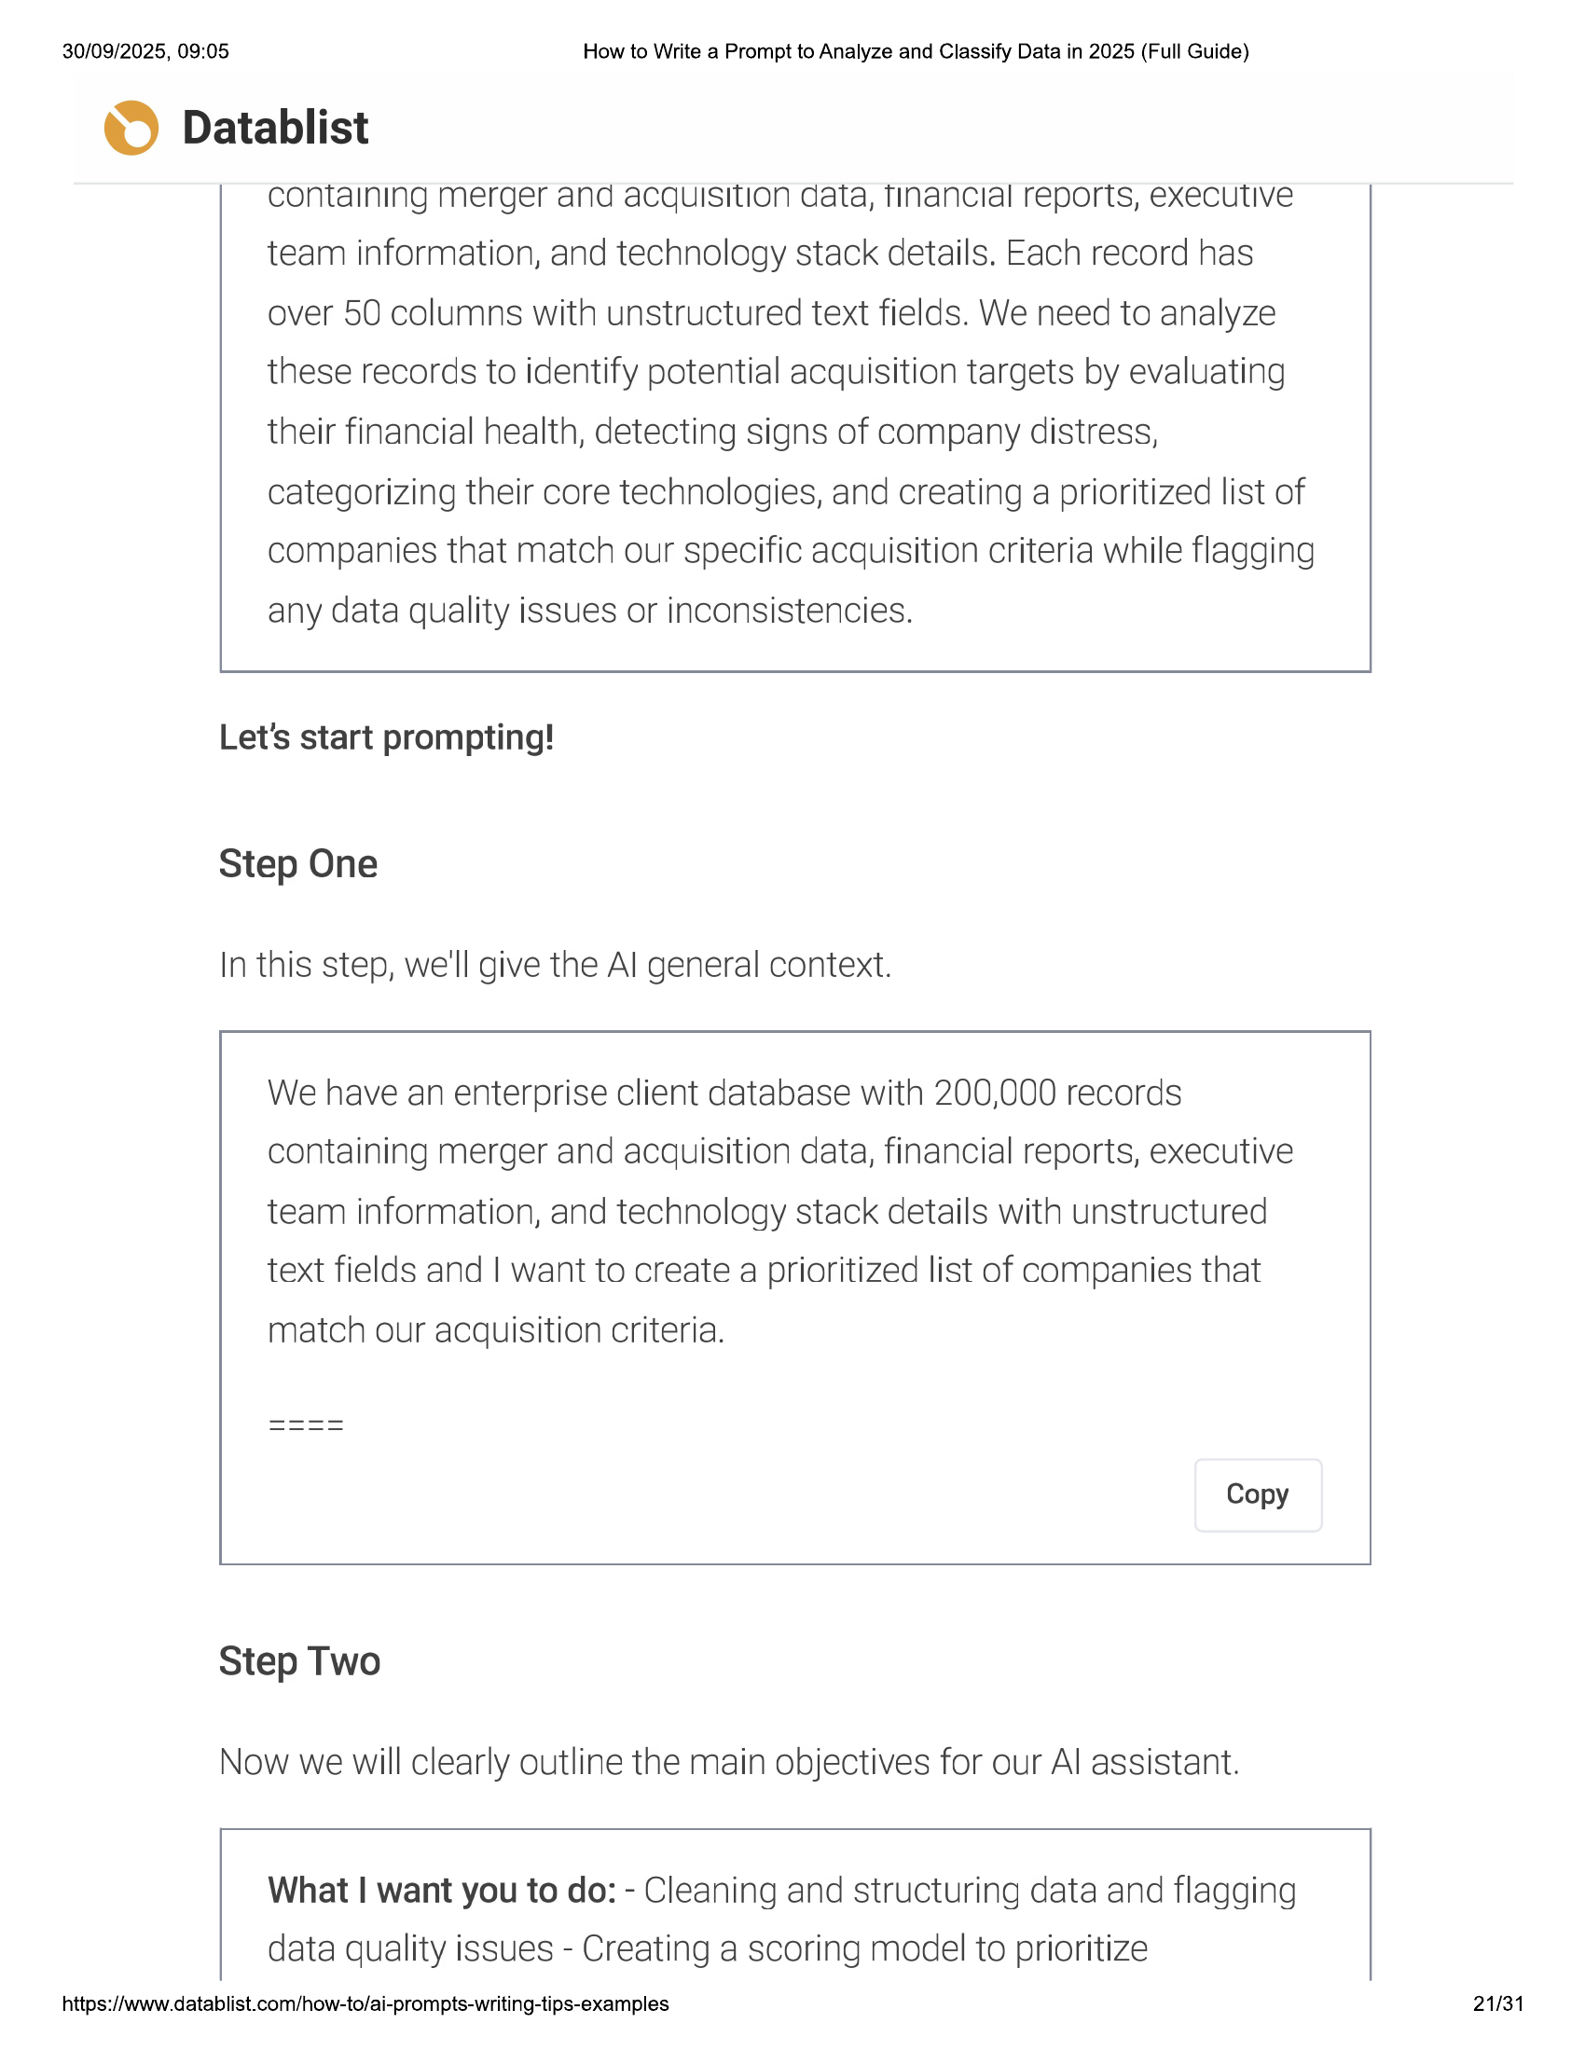

30/09/2025, 09:05 How to Write a Prompt to Analyze and Classify Data in 2025 (Full Guide)  
  
© Datablist  
  
containing merger and acquisition data, financial reports, executive  
team information, and technology stack details. Each record has  
  
over 50 columns with unstructured text fields. We need to analyze  
these records to identify potential acquisition targets by evaluating  
their financial health, detecting signs of company distress,  
categorizing their core technologies, and creating a prioritized list of  
companies that match our specific acquisition criteria while flagging  
any data quality issues or inconsistencies.  
  
Let's start prompting!  
  
Step One  
  
In this step, we'll give the Al general context.  
  
We have an enterprise client database with 200,000 records  
containing merger and acquisition data, financial reports, executive  
  
team information, and technology stack details with unstructured  
text fields and | want to create a prioritized list of companies that  
  
match our acquisition criteria.  
  
Copy  
  
Step Two  
  
Now we will clearly outline the main objectives for our Al assistant.  
  
What | want you to do: - Cleaning and structuring data and flagging  
data quality issues - Creating a scoring model to prioritize  
  
https://www.datablist.com/how-to/ai-prompts-writing-tips-examples  
  
21/31

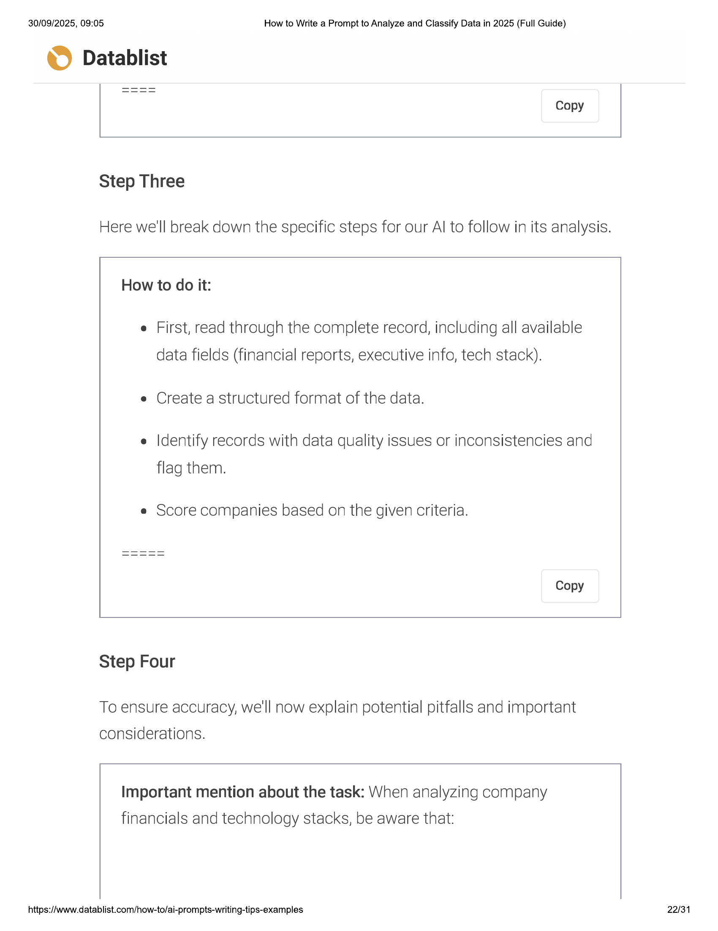

30/09/2025, 09:05 How to Write a Prompt to Analyze and Classify Data in 2025 (Full Guide)  
  
© Datablist  
  
Copy  
  
Step Three  
  
Here we'll break down the specific steps for our Al to follow in its analysis.  
  
How to do it:  
  
e First, read through the complete record, including all available  
data fields (financial reports, executive info, tech stack).  
  
e Create a structured format of the data.  
  
e Identify records with data quality issues or inconsistencies and  
flag them.  
  
e Score companies based on the given criteria.  
  
Copy  
  
Step Four  
  
To ensure accuracy, we'll now explain potential pitfalls and important  
considerations.  
  
Important mention about the task: When analyzing company  
financials and technology stacks, be aware that:  
  
https://www.datablist.com/how-to/ai-prompts-writing-tips-examples  
  
22/31

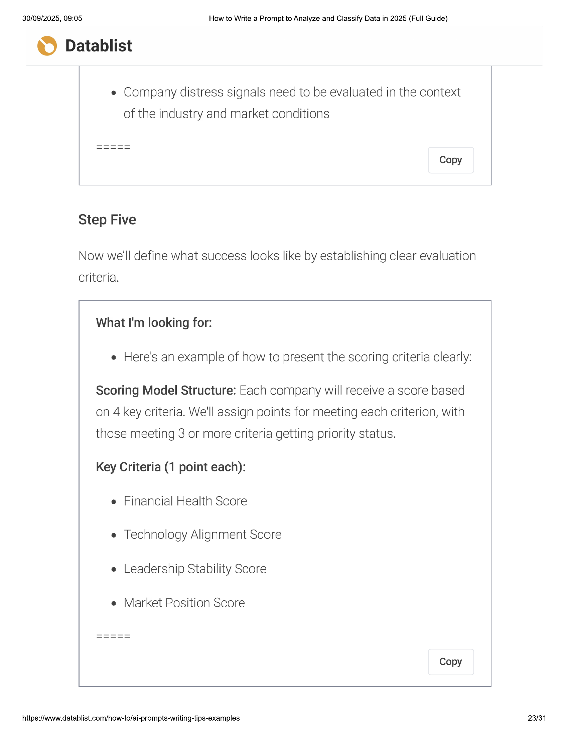

30/09/2025, 09:05 How to Write a Prompt to Analyze and Classify Data in 2025 (Full Guide)  
  
© Datablist  
  
e Company distress signals need to be evaluated in the context  
of the industry and market conditions  
  
Copy  
  
Step Five  
  
Now we'll define what success looks like by establishing clear evaluation  
criteria.  
  
What I'm looking for:  
  
e Here's an example of how to present the scoring criteria clearly:  
  
Scoring Model Structure: Each company will receive a score based  
on 4 key criteria. We'll assign points for meeting each criterion, with  
those meeting 3 or more criteria getting priority status.  
  
Key Criteria (1 point each):  
e Financial Health Score  
e Technology Alignment Score  
e Leadership Stability Score  
  
e Market Position Score  
  
Copy  
  
https://www.datablist.com/how-to/ai-prompts-writing-tips-examples  
  
23/31

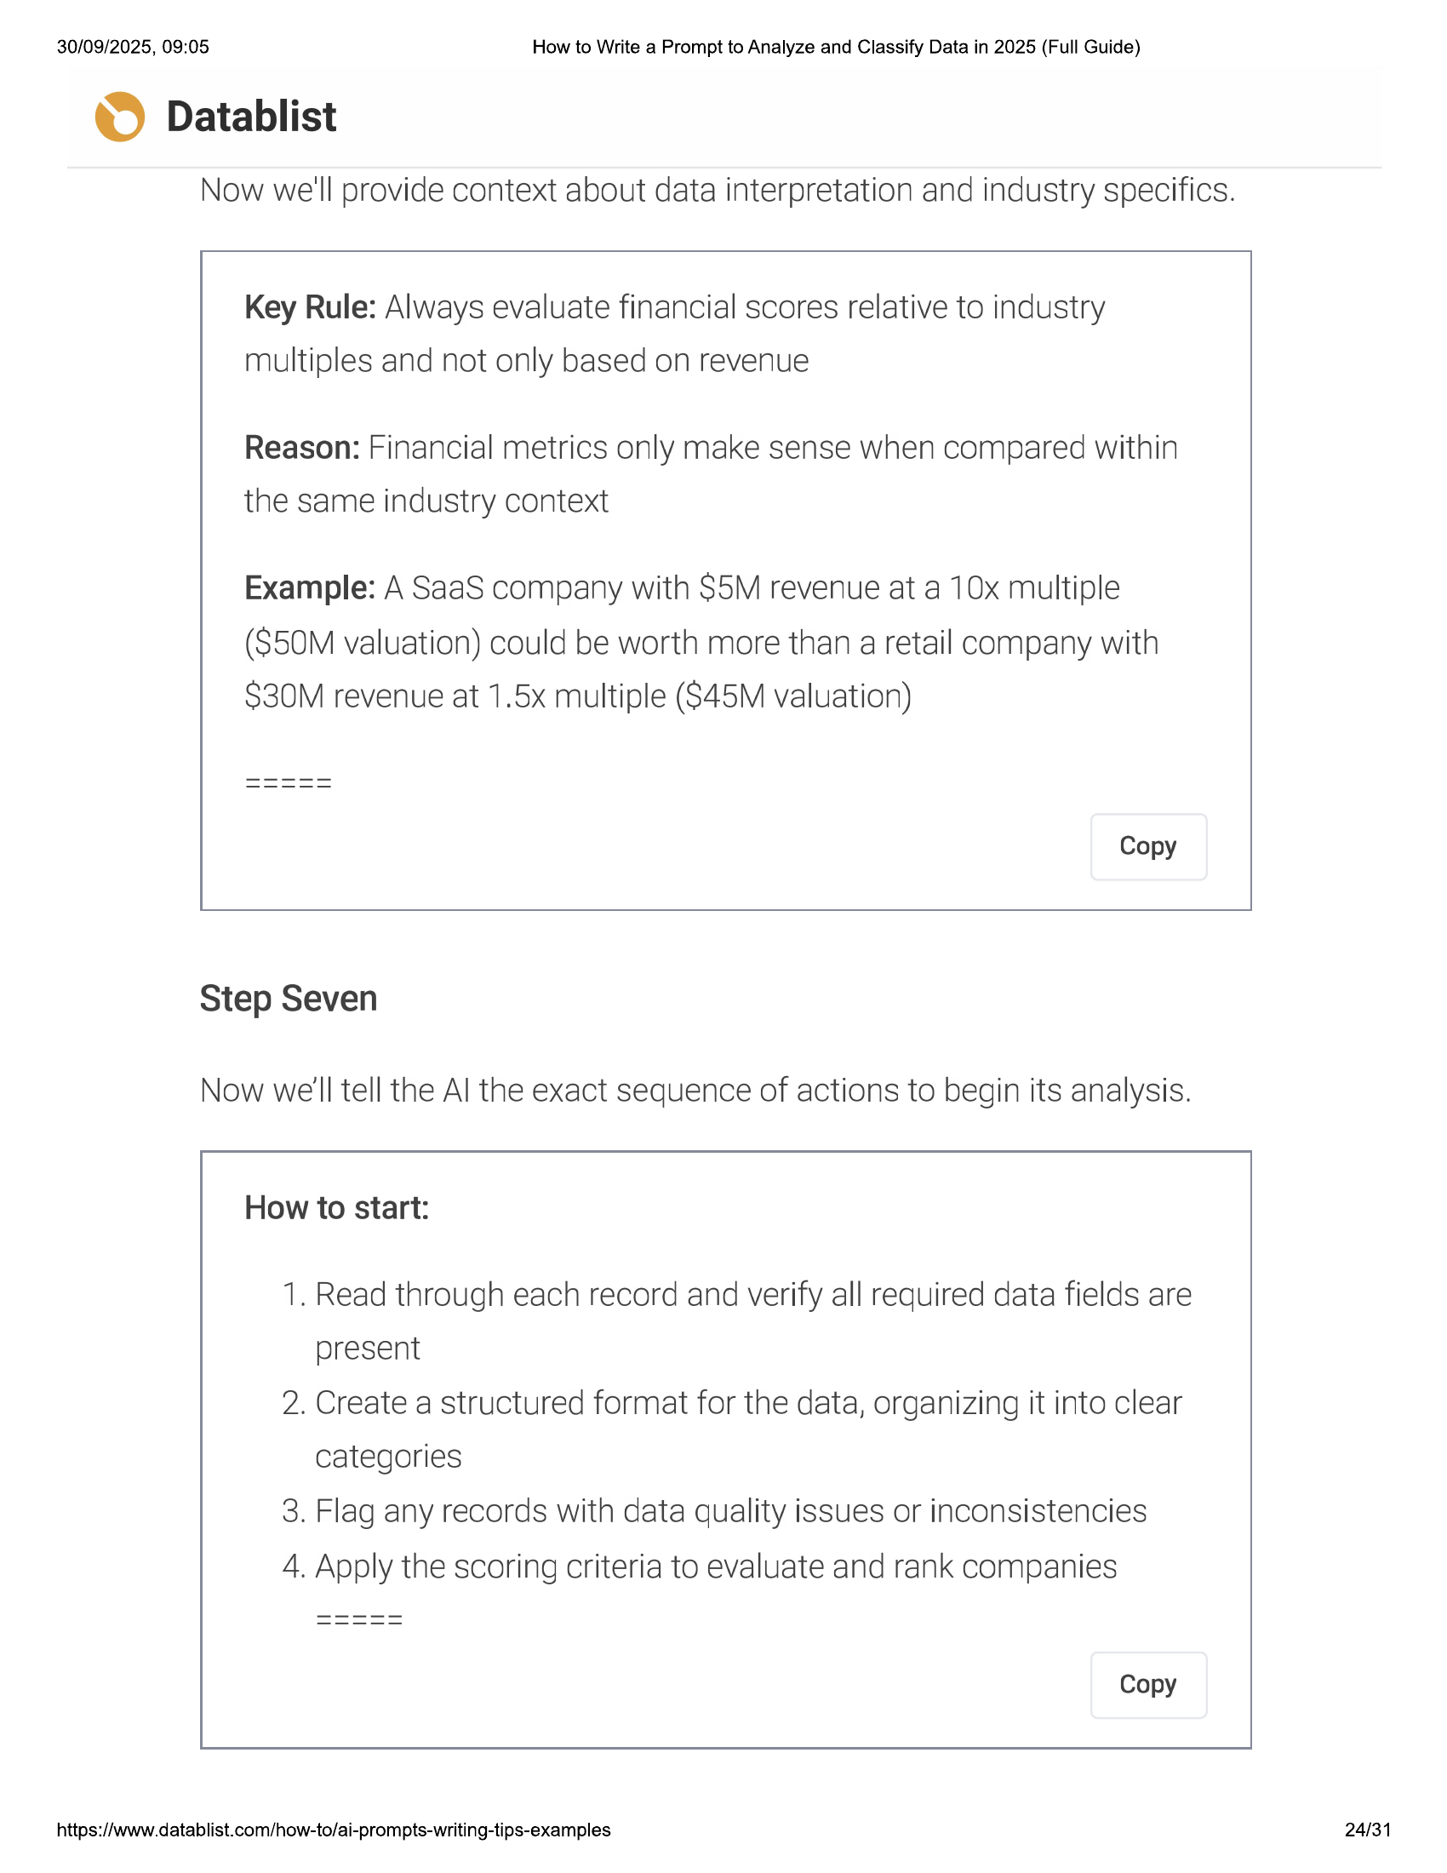

30/09/2025, 09:05 How to Write a Prompt to Analyze and Classify Data in 2025 (Full Guide)  
  
© Datablist  
  
Now we'll provide context about data interpretation and industry specifics.  
  
Key Rule: Always evaluate financial scores relative to industry  
multiples and not only based on revenue  
  
Reason: Financial metrics only make sense when compared within  
the same industry context  
  
Example: A SaaS company with S5M revenue at a 10x multiple  
(S50M valuation) could be worth more than a retail company with  
$30M revenue at 1.5x multiple (S$45M valuation)  
  
Copy  
  
Step Seven  
  
Now we'll tell the Al the exact sequence of actions to begin its analysis.  
  
How to start:  
  
1, Read through each record and verify all required data fields are  
present  
  
2. Create a structured format for the data, organizing it into clear  
categories  
  
3. Flag any records with data quality issues or inconsistencies  
  
4. Apply the scoring criteria to evaluate and rank companies  
  
Copy  
  
https://www.datablist.com/how-to/ai-prompts-writing-tips-examples  
  
24/31

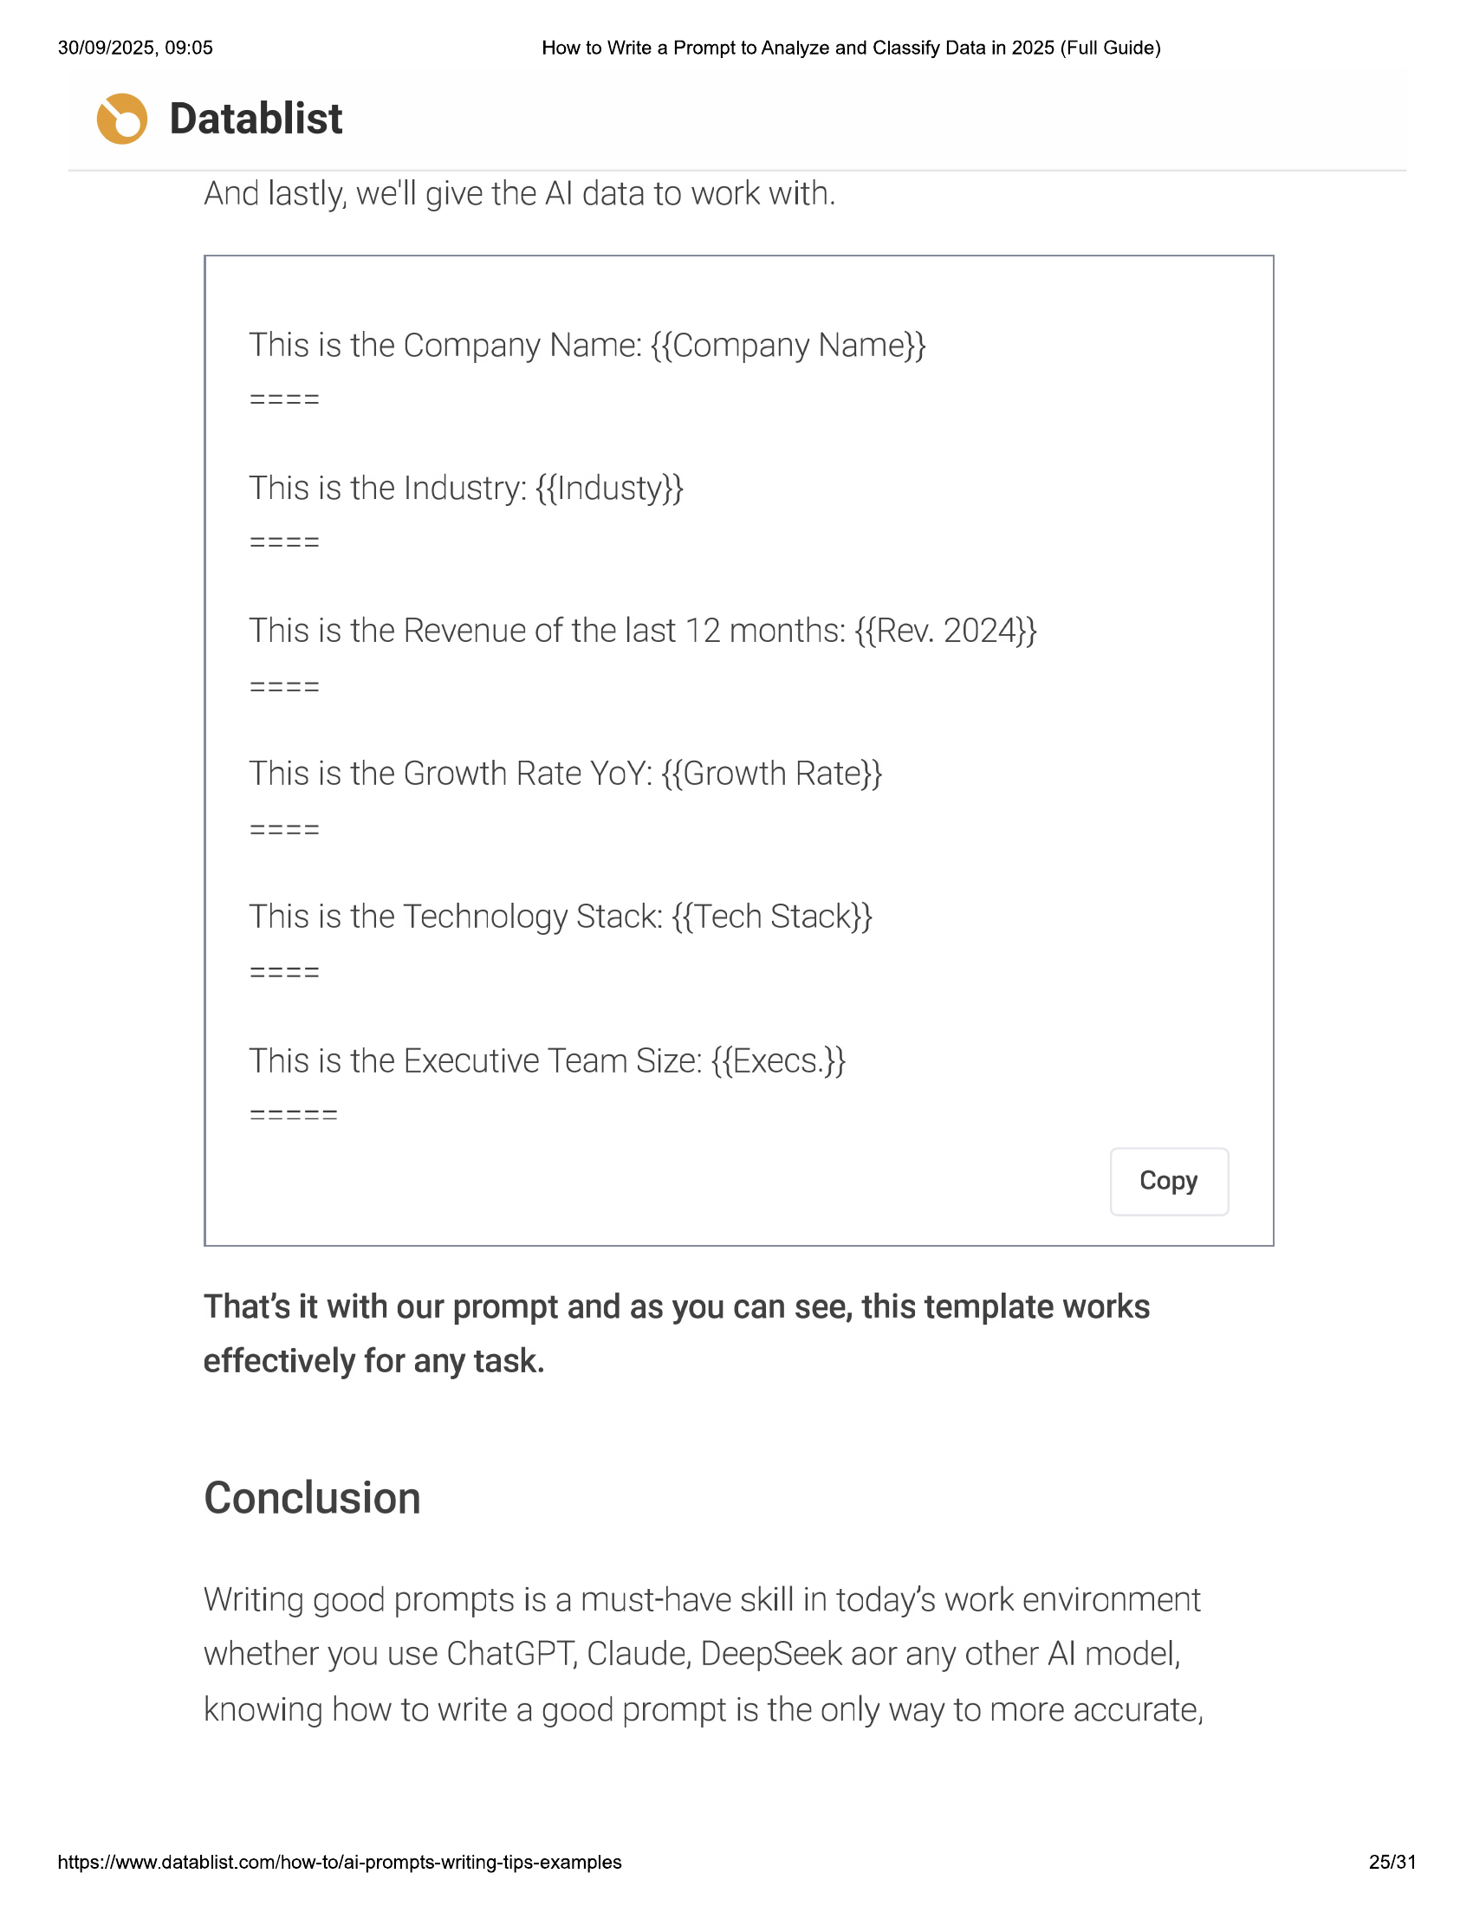

30/09/2025, 09:05  
  
How to Write a Prompt to Analyze and Classify Data in 2025 (Full Guide)  
  
© Datablist  
  
And |  
  
astly, we'll give the Al data to work with.  
  
This is the Company Name: {{Company Name}}  
  
This is the Industry: {{Industy}}  
  
T  
  
his is the Revenue of the last 12 months: {{Rev. 2024}}  
  
This is the Growth Rate YoY: {{Growth Rate}}  
  
This is the Executive Team Size: {{Execs.}}  
  
Copy  
  
That  
  
's it with our prompt and as you can see, this template works  
  
effectively for any task.  
  
Conclusion  
  
Writi  
  
ng good prompts is a must-have skill in today’s work environment  
  
whether you use ChatGPT, Claude, DeepSeek aor any other Al model,  
  
knowing how to write a good prompt is the only way to more accurate,  
  
https://www.datablist.com/how-to/ai-prompts-writing-tips-examples  
  
25/31

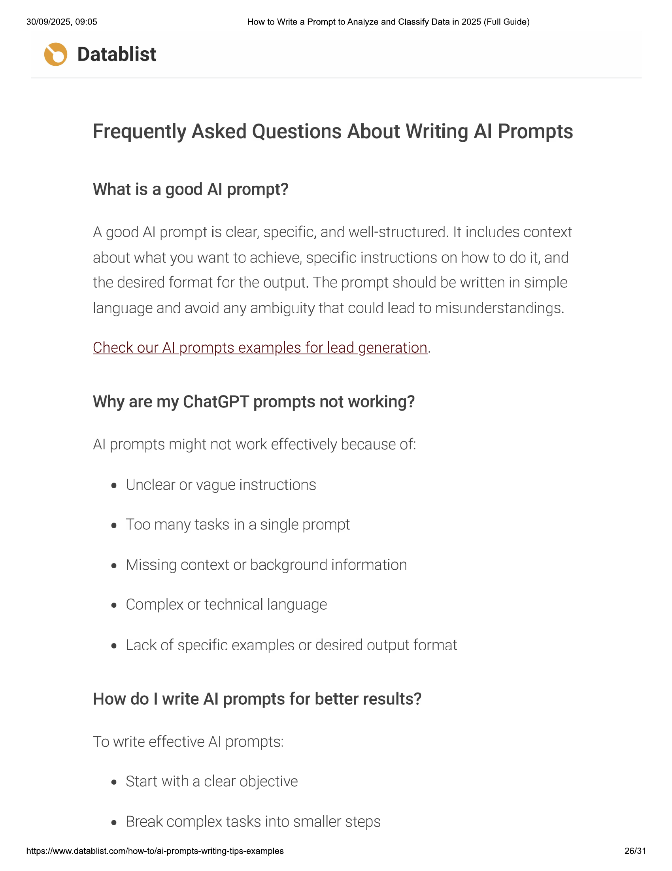

30/09/2025, 09:05 How to Write a Prompt to Analyze and Classify Data in 2025 (Full Guide)  
  
© Datablist  
  
Frequently Asked Questions About Writing Al Prompts  
  
What is a good Al prompt?  
  
A good Al prompt is clear, specific, and well-structured. It includes context  
about what you want to achieve, specific instructions on how to do it, and  
the desired format for the output. The prompt should be written in simple  
language and avoid any ambiguity that could lead to misunderstandings.  
  
Check our Al prompts examples for lead generation.  
  
Why are my ChatGPT prompts not working?  
Al prompts might not work effectively because of:  
e Unclear or vague instructions  
  
e Too many tasks in a single prompt  
  
Missing context or background information  
e Complex or technical language  
  
e Lack of specific examples or desired output format  
  
How do | write Al prompts for better results?  
To write effective Al prompts:  
e Start with a clear objective  
  
e Break complex tasks into smaller steps  
  
https://www.datablist.com/how-to/ai-prompts-writing-tips-examples 26/31

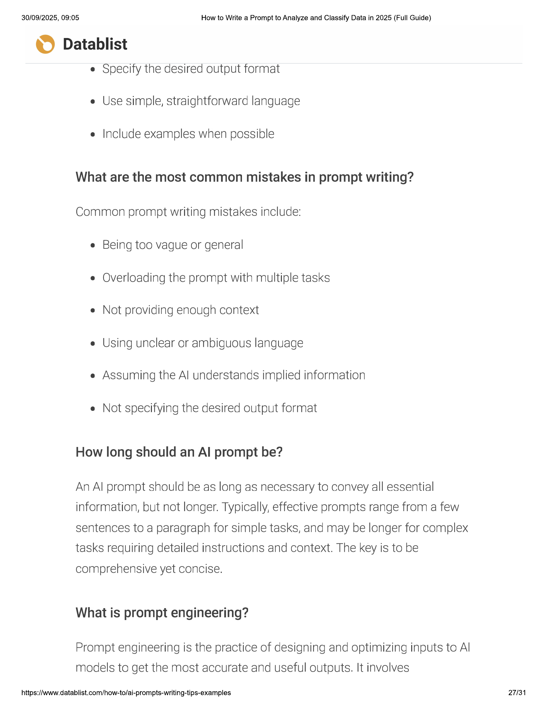

30/09/2025, 09:05 How to Write a Prompt to Analyze and Classify Data in 2025 (Full Guide)  
  
© Datablist  
  
e Specify the desired output format  
e Use simple, straightforward language  
  
e Include examples when possible  
  
What are the most common mistakes in prompt writing?  
Common prompt writing mistakes include:  
  
e Being too vague or general  
  
e Overloading the prompt with multiple tasks  
  
e Not providing enough context  
  
e Using unclear or ambiguous language  
  
e Assuming the Al understands implied information  
  
e Not specifying the desired output format  
  
How long should an Al prompt be?  
  
An Al prompt should be as long as necessary to convey all essential  
information, but not longer. Typically, effective prompts range from a few  
sentences to a paragraph for simple tasks, and may be longer for complex  
tasks requiring detailed instructions and context. The key is to be  
  
comprehensive yet concise.  
  
What is prompt engineering?  
  
Prompt engineering is the practice of designing and optimizing inputs to Al  
models to get the most accurate and useful outputs. It involves  
  
https://www.datablist.com/how-to/ai-prompts-writing-tips-examples 27/31

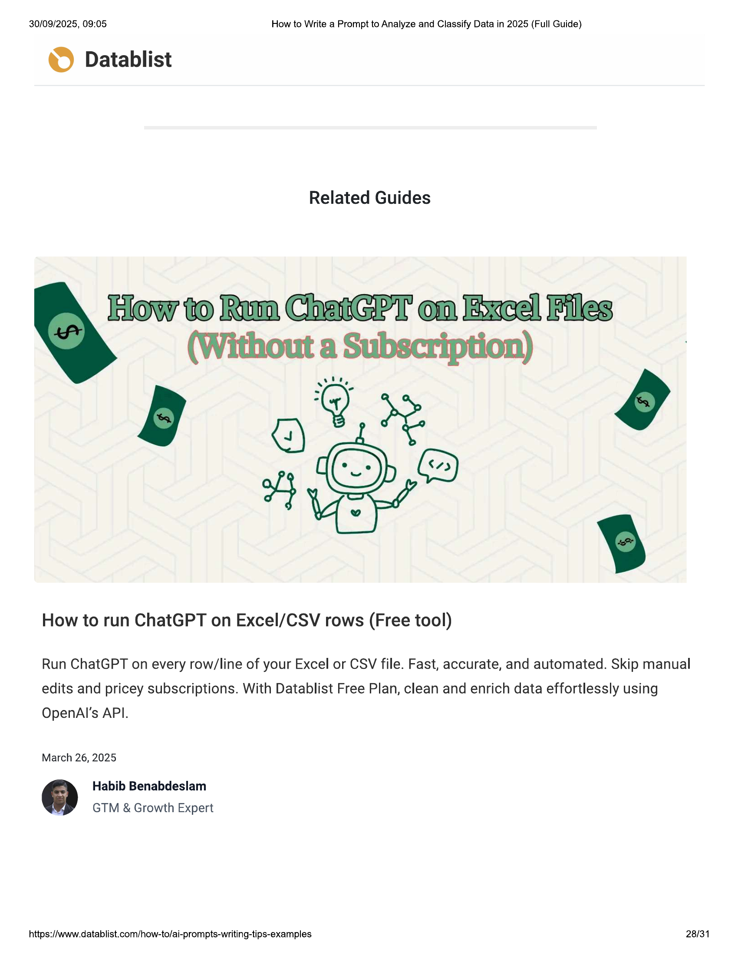

30/09/2025, 09:05 How to Write a Prompt to Analyze and Classify Data in 2025 (Full Guide)  
  
© Datablist  
  
Related Guides  
  
How to run ChatGPT on Excel/CSV rows (Free tool)  
  
Run ChatGPT on every row/line of your Excel or CSV file. Fast, accurate, and automated. Skip manual  
edits and pricey subscriptions. With Datablist Free Plan, clean and enrich data effortlessly using  
  
OpenAl'’s API.  
  
March 26, 2025  
  
Habib Benabdeslam  
GTM & Growth Expert  
  
https://www.datablist.com/how-to/ai-prompts-writing-tips-examples 28/31

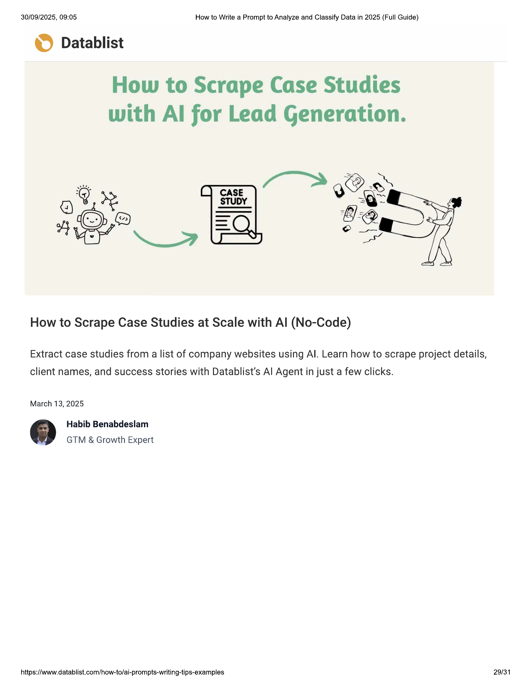

30/09/2025, 09:05 How to Write a Prompt to Analyze and Classify Data in 2025 (Full Guide)  
  
© Datablist  
  
How to Scrape Case Studies  
with Al for Lead Generation.  
  
How to Scrape Case Studies at Scale with Al (No-Code)  
  
Extract case studies from a list of company websites using Al. Learn how to scrape project details,  
  
client names, and success stories with Datablist’s Al Agent in just a few clicks.  
  
March 13, 2025  
  
Habib Benabdeslam  
GTM & Growth Expert  
  
https://www.datablist.com/how-to/ai-prompts-writing-tips-examples 29/31

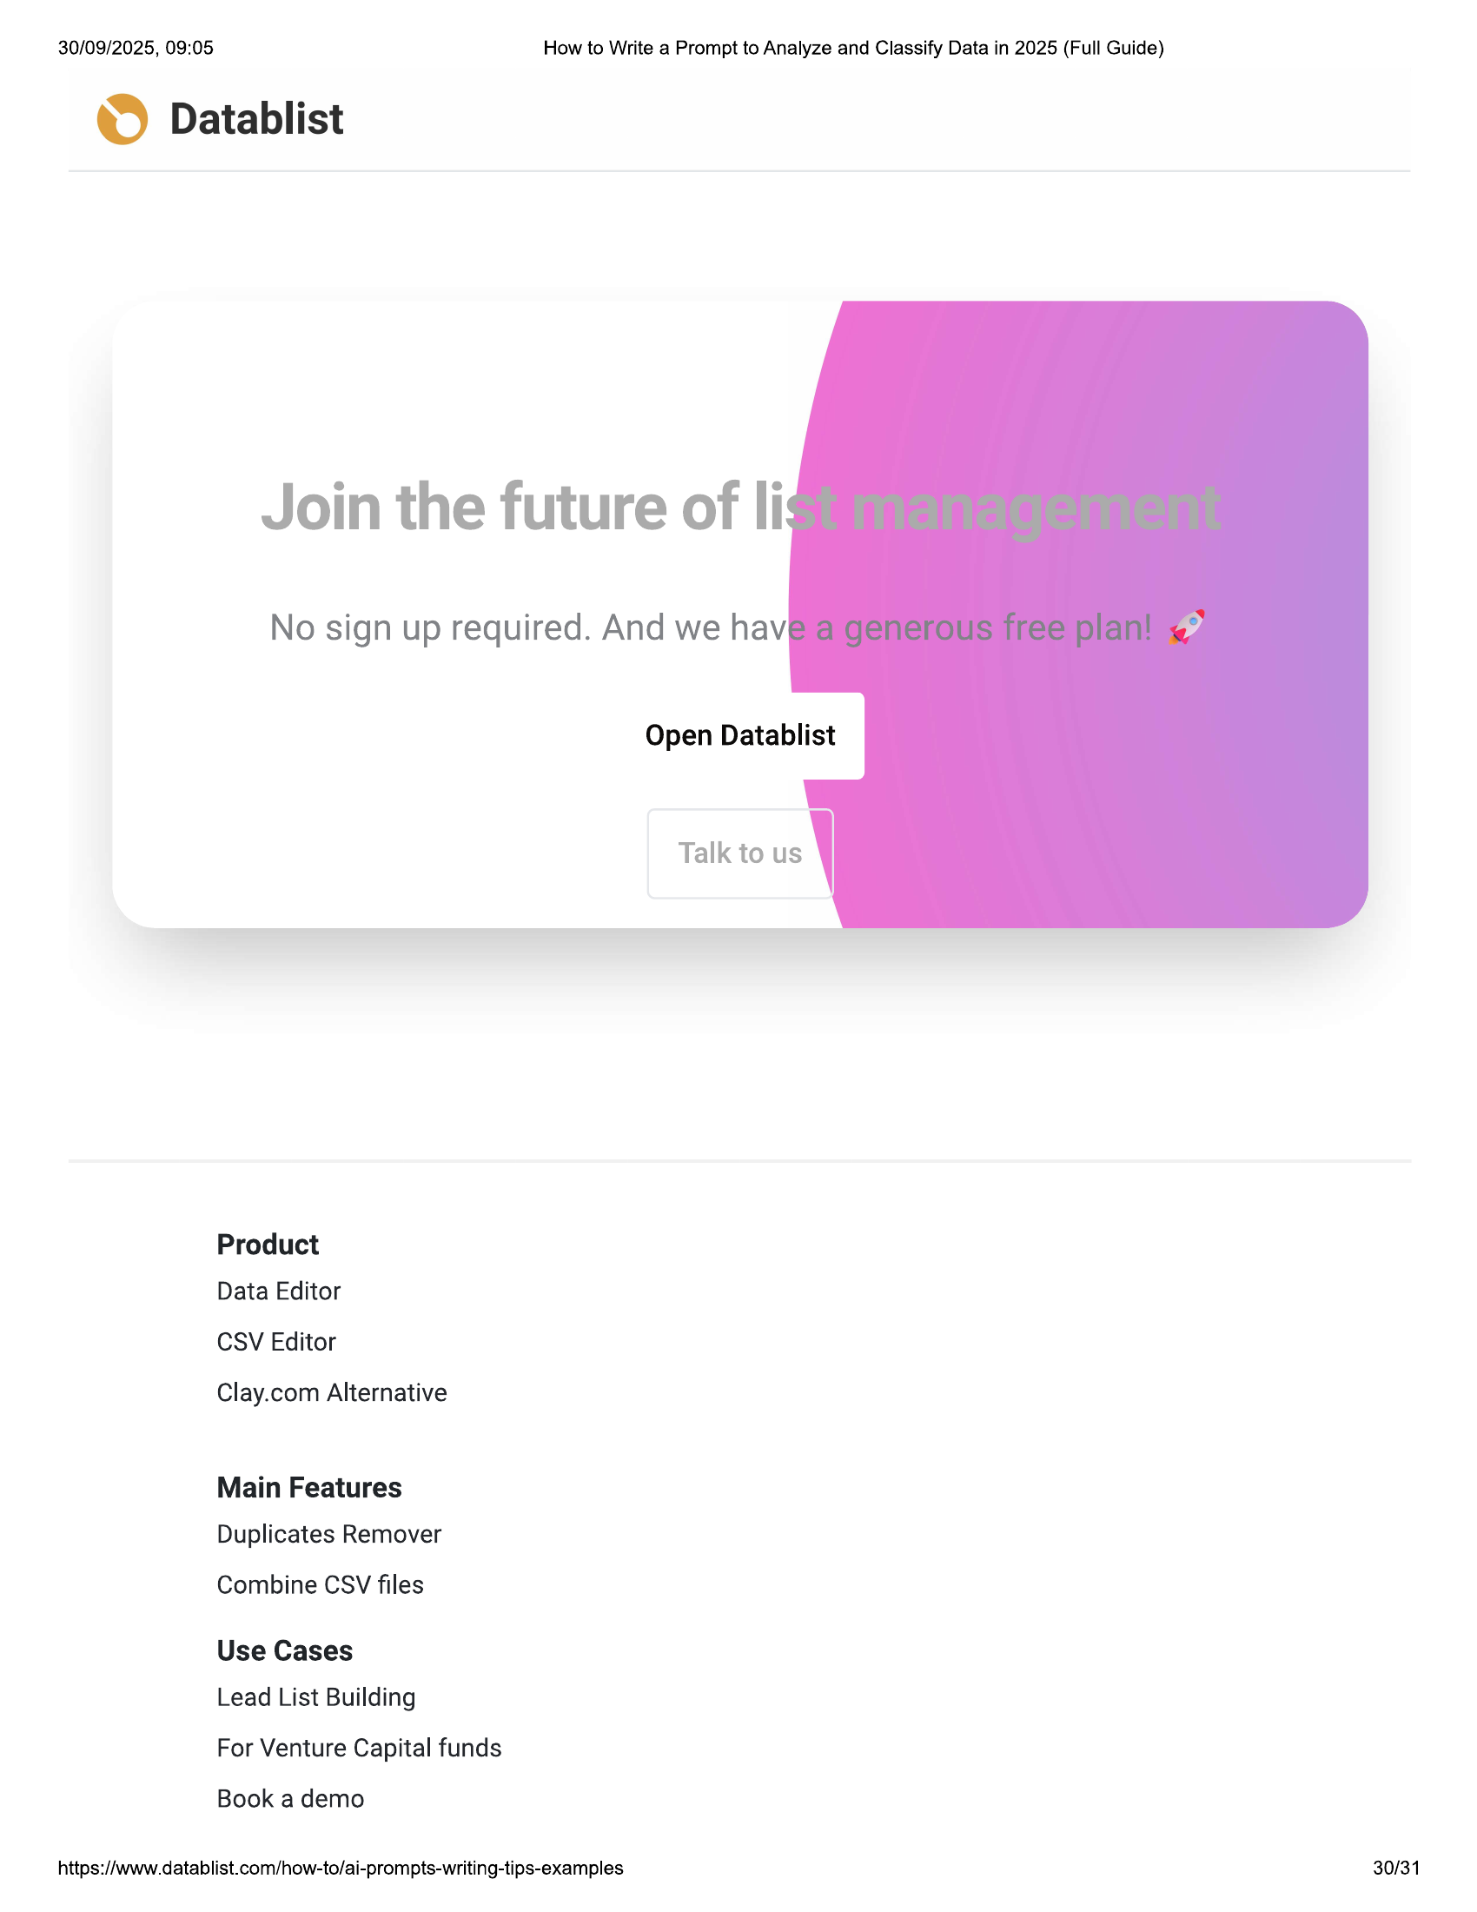

30/09/2025, 09:05  
  
How to Write a Prompt to Analyze and Classify Data in 2025 (Full Guide)  
  
© Datablist  
  
Join the future of li  
  
No sign up required. And we hav  
  
Product  
Data Editor  
  
CSV Editor  
  
Clay.com Alternative  
  
Main Features  
Duplicates Remover  
  
Combine CSV files  
  
Use Cases  
Lead List Building  
  
For Venture Capital funds  
  
Book a demo  
  
https://www.datablist.com/how-to/ai-prompts-writing-tips-examples  
  
Open Datablist  
  
Talk to us  
  
\  
  
30/31

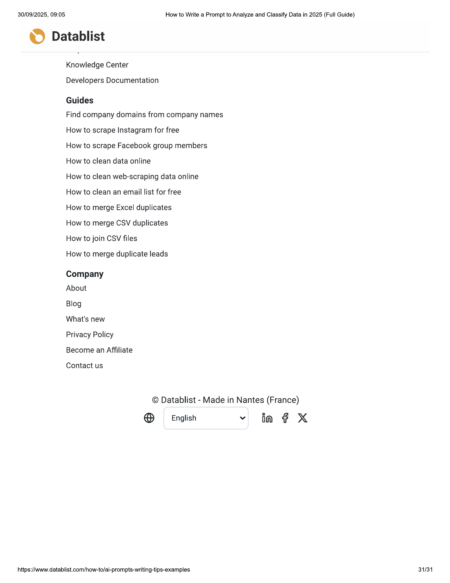

30/09/2025, 09:05 How to Write a Prompt to Analyze and Classify Data in 2025 (Full Guide)  
  
© Datablist  
  
Knowledge Center  
  
Developers Documentation  
  
Guides  
  
Find company domains from company names  
How to scrape Instagram for free  
  
How to scrape Facebook group members  
How to clean data online  
  
How to clean web-scraping data online  
How to clean an email list for free  
  
How to merge Excel duplicates  
  
How to merge CSV duplicates  
  
How to join CSV files  
  
How to merge duplicate leads  
Company  
  
About  
  
Blog  
  
What's new  
  
Privacy Policy  
  
Become an Affiliate  
  
Contact us  
  
© Datablist - Made in Nantes (France)  
  
® English ~- ia ¢ X  
  
https://www.datablist.com/how-to/ai-prompts-writing-tips-examples 31/31